In *The Evolution of Cooperation*, Axelrod built a model of cooperation that required each agent to remember its past interactions with every other agent. In *The Evolution of Ethnocentric Behavior*, Axelrod and Hammond build a model of cooperation that requires much less knowledge and thought on behalf of the agent. It relies on spatial locality—both in groups and interactions—to create clusters of agents with similar strategies. In this model, there are two ways agents might end up next to each other: either by both being the product of reproduction within a single population, or by two disparate populations growing until they brush up against each other. In the former case, it is highly likely if mutation rate is small that two nearby agents will share the same strategy. In the latter case, no such assumptions can be made. Since agents cannot directly observe each other’s strategies, they need another way to determine their degree of relatedness, and so the observable tag of color serves as a proxy for the likelihood of cooperation—nearby agents with the same color are far more likely to be close relatives that share the same strategy than agents with different colors.

Since this serves as a proxy for how closely related agents are, one logical extension to this would be to extend this from a single tag to multiple tags. Abstractly, we can see the tag as an *n*-dimensional vector that for each mutation moves some small distance in a random direction on each mutation. This is a random walk which we would expect to cause two initially closely related agents to gradually move further apart over time.

One simple way to implement this is to create a tag string consisting of a variable number *n* of bits, each of which is initially set randomly and which, when an agent reproduces, is copied to each offspring with each bit having some small random chance to be flipped. We can then measure the degree of similarity between two agents as the Hamming distance between their two tag strings. If we are considering this as a sociological model, we might think of each bit as representing some observable characteristic of an individual. One bit might represent skin color, another nose shape, religion, etc. One assumption we are making is that the value of each bit is something the agent is incapable of changing (we may revisit this later) and that they are stuck with what they are born with. It is possible that in deciding whether or not to cooperate, an agent may place more weight on differences in some bits than others, or that some bits may have higher rates of mutation than others, however as a first assessment, we are going to assume that each bit is weighted equally and has an equal chance of mutation. We may revisit implications of other models later.

*The Evolution of Ethnocentric Behavior* implements four strategies: CC (cooperator), CD (ethnocentric), DC (cosmopolitan) and DD (cheater). To allow us to extend the model from its original behavior, we implement these strategies in terms of two variables: different-threshold, the value of Hamming distance with another agent which, if met or exceeded, will alter an agent’s decision to cooperate or not, and is-cosmopolitan?. If set to false, an agent will cooperate with agents whose Hamming distance is < different-threshold and defect with agents whose Hamming distance is ≥ different-threshold. If set to true, these behaviors are inverted so an agent defects with agents Hamming distance is < different-threshold and cooperates otherwise. To allow for “color-blind” cases, we allow cooperation-threshold to go a little way outside of the range of possible values for Hamming distance, so for example in the 1-tag case, we set the range of possible values for cooperation-threshold to [0,2].

We can reproduce the strategies of the two-color Axelrod and Hammond model by setting *n* = 1 and setting thresholds for each strategy as follows:

* CC: different-threshold = 2, is-cosmopolitan? = false, or different-threshold = 0, is-cosmopolitan? = true
* CD: different-threshold = 1, is-cosmopolitan? = false
* DC: different-threshold = 1, is-cosmopolitan? = true
* DD: different-threshold = 2, is-cosmopolitan? = true, or different-threshold = 0, is-cosmopolitan? = false

We can also reproduce the single-color case given by Axelrod and Hammond simply by setting *n* = 1. Reproducing their mutation system with these parameters is slightly more complicated.

Before I do any of this, I want to do a non-functional re-write of Wilensky’s rather poorly organized code to make it more readable and easier to test, debug, and expand on. There are also a great many statistics collected on individual interactions that I will not have use for, which I will eliminate. To verify that this really is a completely non-functional rewrite, I will do a series of BehaviorSpace runs, varying different parameters, with a fixed random seed. I will then do the same runs with the same random seeds after the rewrite. If the rewrite has not had a functional effect, the output data should be identical. I am testing only a few different possible permutations of parameters, which I believe should be sufficient to establish functional identity. (I have already eliminated the immigrate and immigration-rate functions. Since I had already set immigration-rate to 0, it is self-evident that this should not change the run results.)

Dynamics of an initial test run look a little odd:

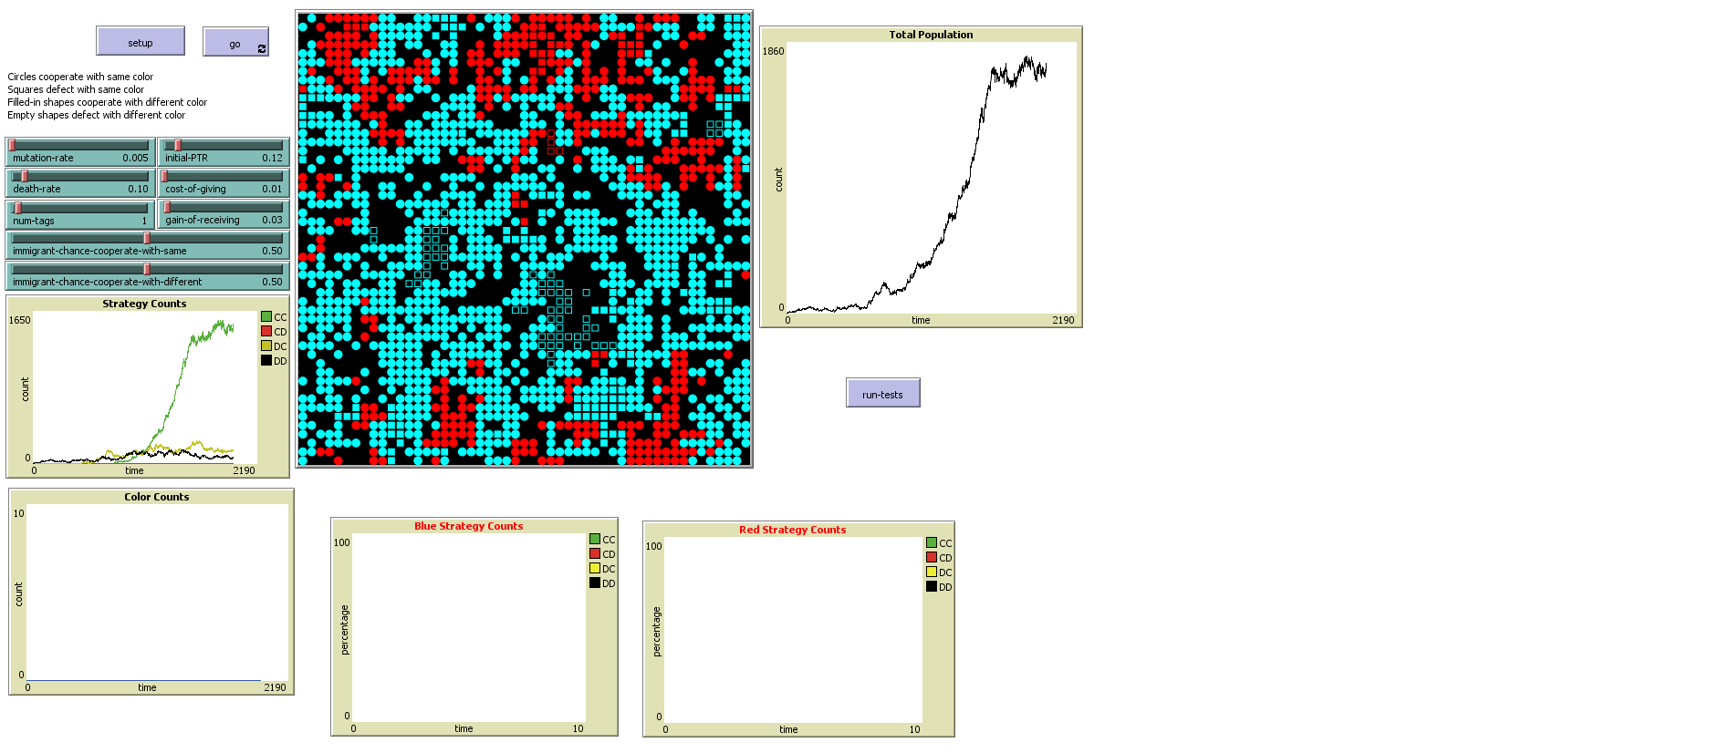

So we probably made a mistake somewhere, as the usually dominant “CD” strategy has yet to appear at all after over 2,000 ticks. The first agents were “DD” and appeared first and remained dominant for a long time. Then “DC” appeared and gradually supplanted it. When “CC” appeared, it quickly grew strongly dominant, which is unusual. It could be an error in our logic, or in the way we report strategies.

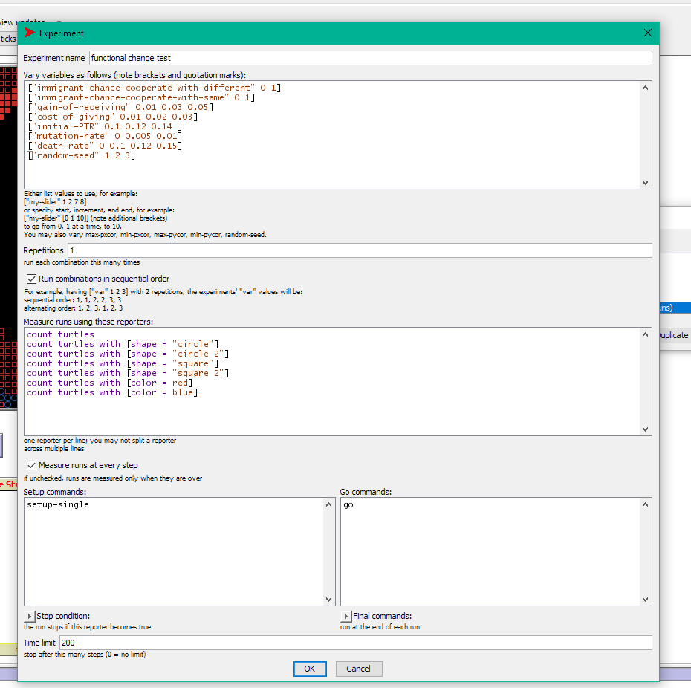

We run the BehaviorSpace test above first before making any changes, and again afterwards. After an initial non-functional change, we compare the two files:

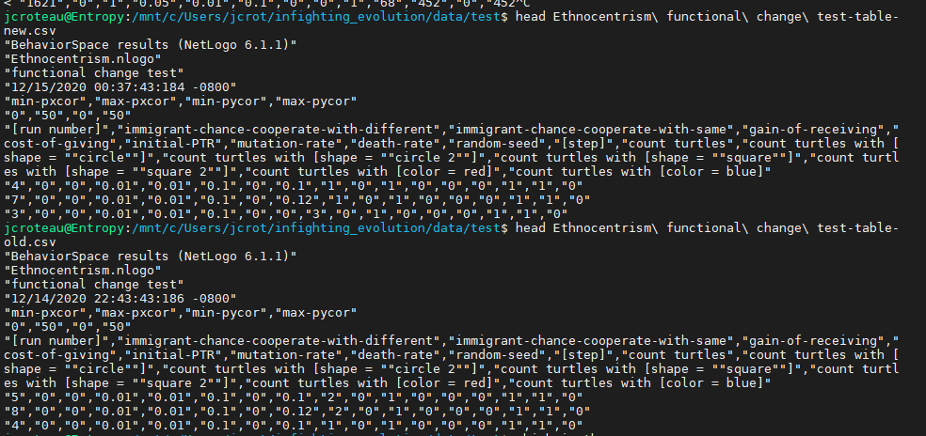

While the headers match, we see an obvious problem: for computational efficiency, runs were made in parallel, which means that individual datapoints are output in random order. This means a simple file comparison will not work. We can however resolve this and verify that the underlying data is identical simply by sorting the files first and then comparing:

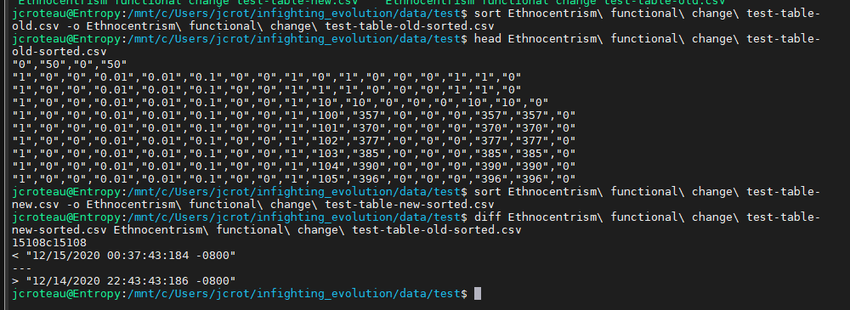

This verifies that the non-functional change is in fact a non-functional change, with the only difference in the two files being the timestamps, and underlying data generated being identical. Both files output a total of 290,075 lines (including 7 header lines) from 3,888 runs, which is about what we would expect given that runs were capped at 200 ticks, data was output for each tick, and some runs ended early when the population went extinct.

For ease of visualization, I moved the origin to the center (it had originally been in the lower left corner). This is very clearly a non-functional change as the overall topology is still toroidal. I did this so that the initial agent created would appear in the center of the map, making it more obvious what’s going on. I have also changed the colorization to HSB, which will make visualization with a larger number of tags easier.

Added integrated test code with run-tests method, including code to test test methods. This is not run as part of the normal setup routine because it includes a large number of calls to runresult with a string argument, which requires compilation and would slow the setup process. It has a button to run it at any time.

Since hamming distance is an integer, it makes sense to have difference-threshold be an integer too. If is-cosmopolitan? = false, then an agent will cooperate when hamming-distance < difference-threshold. This means the “always cooperate” strategy is equivalent to difference-threshold = num-tags + 1, and “always defect” is equivalent to difference-threshold = 0 so we bound difference-threshold in the range [0, num-tags + 1]. When mutating, difference-threshold may change by at most 1. If is-cosmopolitan? = false, the agent will defect when hamming-distance < difference-threshold

On initial setup with 1-tag, we selected from the four possible strategies with equal probability. Here, because of the nature of our variables, “CC” and “DD” are twice as likely as the others. I am ignoring this as more detailed examinations will likely not use random initial strategies. If we mutated is-cosmopolitan? at the same rate as the other variables, this would make jumps from “CC” to “DD” or “CD” to “DC” significantly more likely than in the original model, so instead we use a probability of mutation-rate^2. This slightly alters the probability distribution from the original model, though I claim that this change will not significantly alter the dynamics of the model.

An examination of the distribution of values in our turtles quickly shows us a problem:

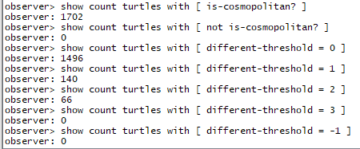

While we have successfully constrained different-threshold in our desired range, we see that the vast majority of turtles have different-threshold = 0 and all of them have is-cosmopolitan? set to true, suggesting an error in our mutation logic. We may perhaps have been overly conservative in our mutation rate for is-cosmopolitan?. It is also somewhat odd from a validation perspective that unconditional cooperation is so strongly selected for over defectors, but not unheard given that this particular run has cost-of-giving set so low. Even in Axelrod and Hammond’s model, they had to set cost-of-giving higher to show a strong advantage for ethnocentrism over pure cooperation.

To address this issue, I set the mutation rate for is-cosmopolitan? back to being the same as other factors. This does make direct jumps from “CC” to “DD” or from “CD” to “DC” somewhat more likely than originally, however I do not believe this is core to the model. Doing a test run now, we see results that are much more familiar:

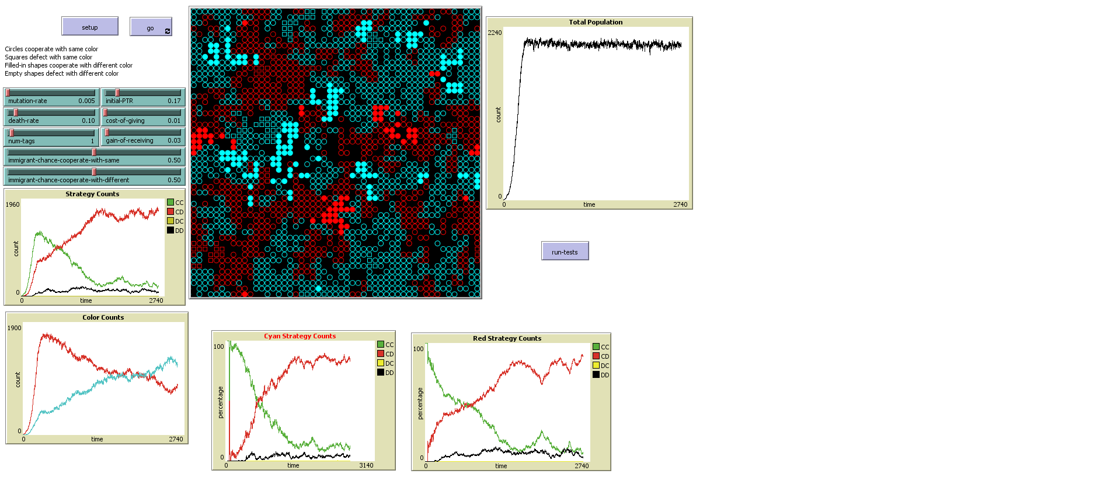

This much more closely resembles the dynamics we have previously observed, with “CC” gaining initial prominence before being crowded out by “CD”. The dynamics over the long term also match what we have previously seen:

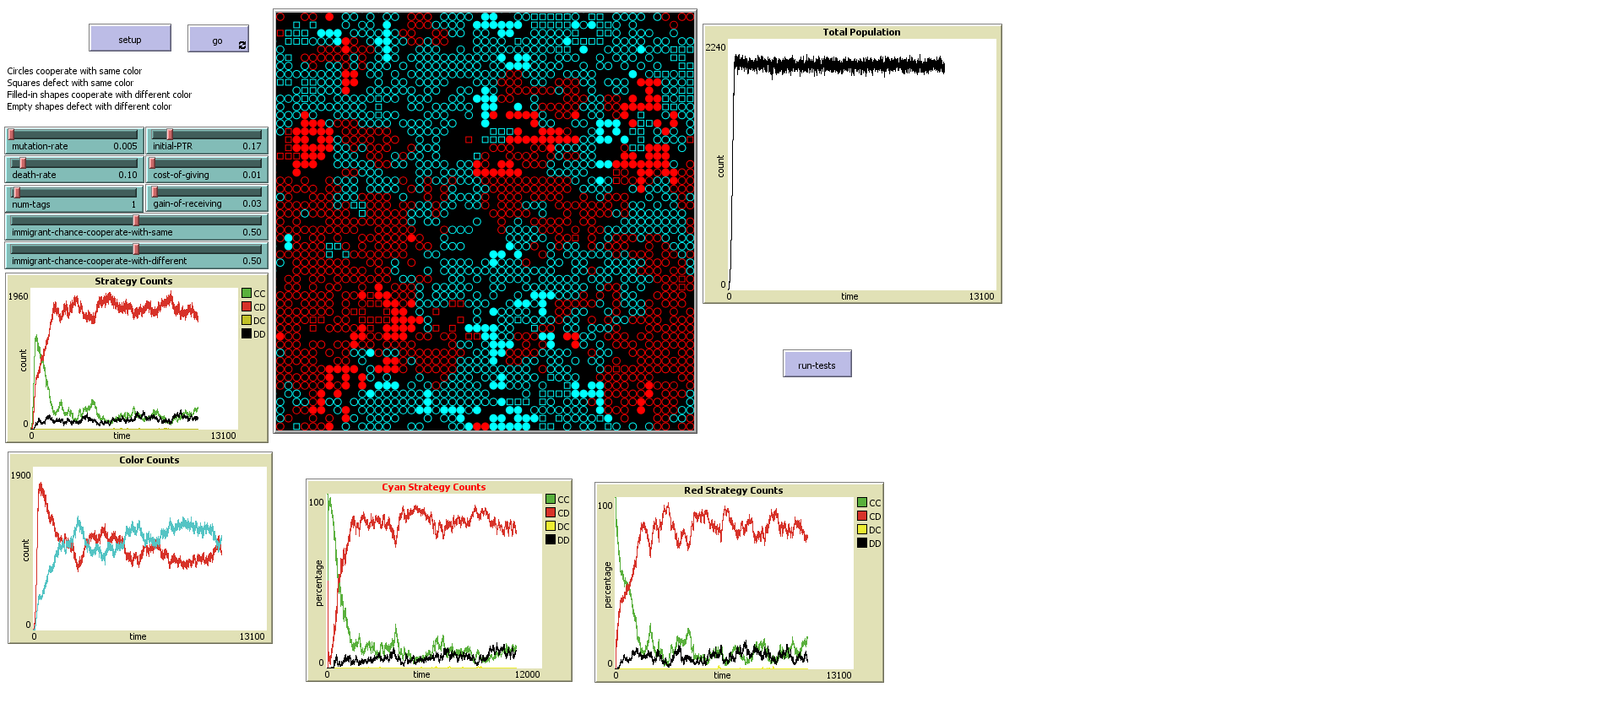

(This is the same run as above, run over a longer period of time)

Though we have verified the model at the macro level for the 1-tag case, we should also do so on the micro level before we proceed to more complex cases. We will do this by adding more unit tests. First, we re-write the code further into smaller sub-modules and then do another quick qualitative check to verify that the results still look correct, which they do. Then we write a suite of tests, all called by the run-tests command. The test suite starts with the most fundamental tests, including testing our test helper methods, and then moves into more advanced integration tests, eventually reaching a full end-to-end test. At each step, since we have already verified that the sub-components work correctly, we don’t need to re-verify every permutation in the larger-scale test. This also means that if something fails, we know the failure is likely in the first failure we see in the run sequence, as smaller modules have already been verified.

After testing deterministic behavior, we also run statistical tests based on expected probability distributions. We consider a test to have passed if the actual observed mean falls within 3 standard deviations of the expected mean (we could in principle set this range to be narrower, but this causes the tests to be flakier, and when a mean is off, it tends to be off by a very large amount). When testing, we set probability values both much smaller and much larger than we actually use in production. The larger values help make sure the probabilities we expect are accurate.

To test mutation under the more complex multi-tag guess we create many turtles, mutate many times, and then look at the probability distribution of each possible tag string, which we expect to follow an approximate binomial distribution. We write a short method to auto-generate every possible tag string, which we can easily test in the command center:



Doing this, we note an oddity in our probability distribution for different-threshold:

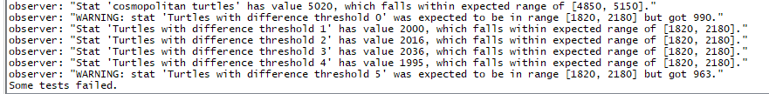

The different-thresholds on the edges of the possible range are both half as likely as those in the middle. This does make sense with a moment’s thought—there are two possible ways to get to every other different-threshold, and only one for the edges. We would like our probability distribution to be even though, so we modify the mutate function to make mutation from one of these edges half as likely. In the long term, this will have the same effect.

Setting this we now end up with a much more even distribution (we also had initially set the expectation value for each different-threshold incorrectly, so fixed that as well):

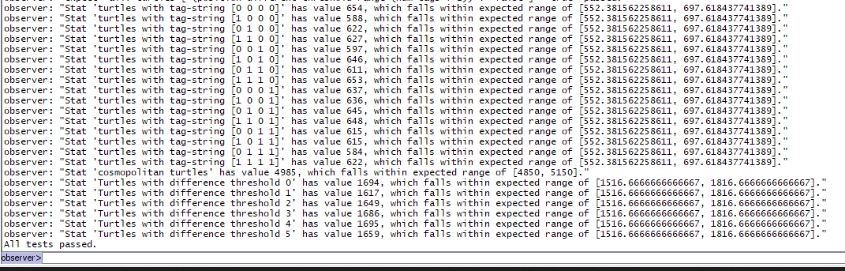

We add tests for reproduction, which pass, and after all that, we are finally ready to do something new. We start off by expanding to a 2-tag system as previously described. To visualize group membership in the 2-tag case, we use the HSB color space and vary hue with the tag string. The tags [0 0] and [1 1] are 180 degrees opposite, as are the tags [0 1] and [1 0], which are 90 degrees opposite from the other pair.

Before we do that, since we slightly altered the model dynamics during testing, we check qualitatively that in the 1-tag case, we still see results that on their face are similar to the original model, which they are. We also take this opportunity to reproduce a result seen in Axelrod and Hammond’s model—that in the 0-tag case (only one color), with cost-of-giving set to 0.2 instead 0.1, that cooperation occurs to a much lesser extent. This will be an import finding in our future explorations. Note in this visualization that we have not updated strategy counts for the 0-tag case

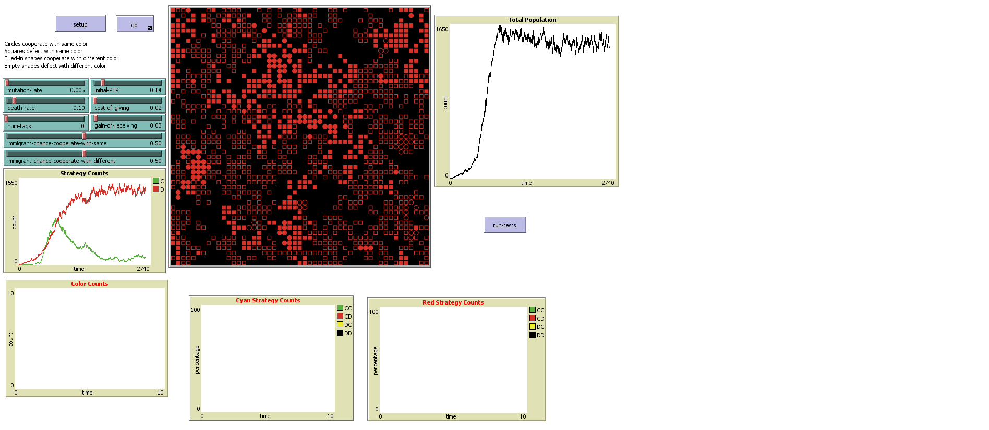

This behavior seems very sensitive to the parameters and reproducing Axelrod and Hammond’s exact result is proving difficult. I can reproduce something quantitively similar using their value of cost-of-giving of 0.02 and gain-of-receiving of 0.03, though it seems much more pronounced when I increase initial-ptr to 0.12. Doing this however seems to cause behavior in the 2-color case to be substantially similar. Perhaps I have subtly altered the model’s behavior, although how is not immediately obvious. I eventually had good results setting death-rate to 0.07, initial-ptr to 0.13, cost-of-giving to 0.02, and gain-of-receiving to 0.04. The sensitivity of this model to small changes in parameters is definitely something I need to explore more. I wonder how much fine-tuning Axelrod and Hammond did. With these parameters, we get this for the 0-tag case:

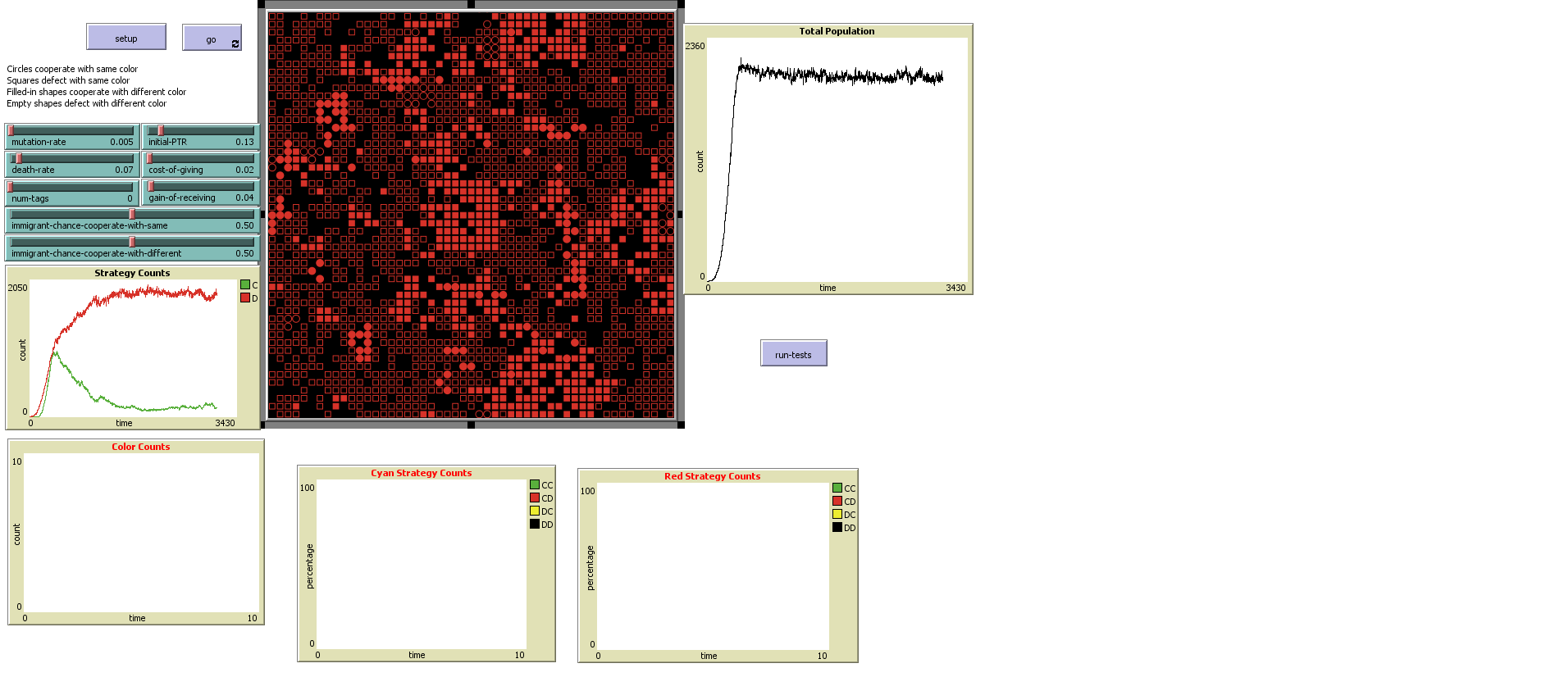

And this for the 1-tag case:

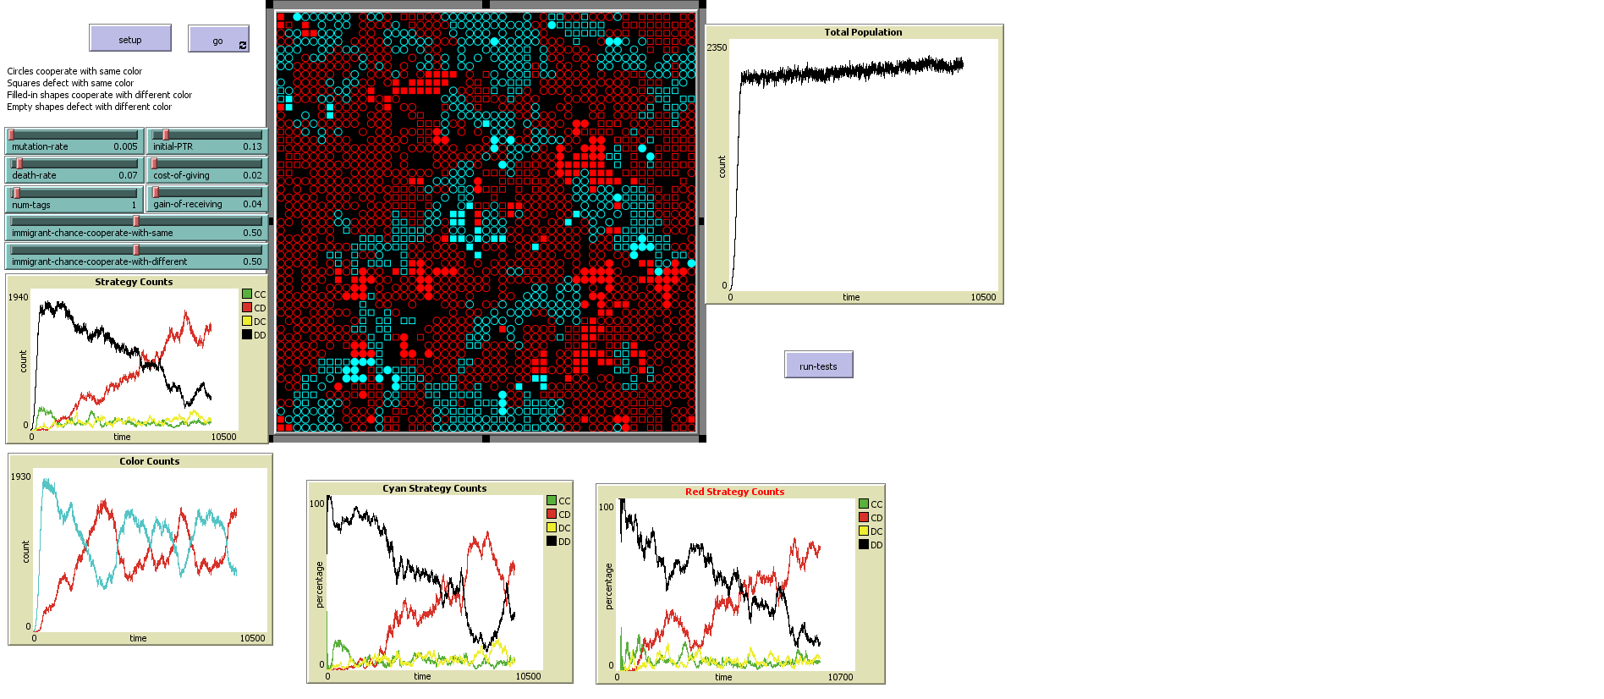

Even here, note that the 0-tag case stabilized fairly quickly, while the 1-tag case took much longer for stable communities of ethnocentric cooperation to develop, and even then, there was much more oscillation. This also differs from previously observed, where usually CC began as the dominant strategy. Possibly I need to reduce the color mutation rate. I will have to examine this more closely. Just to be safe, I added some additional interaction tests with the other strategies to make sure they were being indicated properly. They are. I am also wondering if a larger world would help independent evolution.

Let’s finally try the 2-tag case. I already discussed color. To visualize strategy, I am using a combination of turtle shape and patch color. The shape is a hollow triangle (not using circle because of how hard that is to work with in NetLogo’s shapes editor) if is-cosmopolitan is false, and a hollow square if it is true. The patch will, if is-cosmopolitan is false be darker if difference-threshold is less and brighter if it is more. This does not exactly replicate the original visualization but is close. Finally, we can produce some new data:

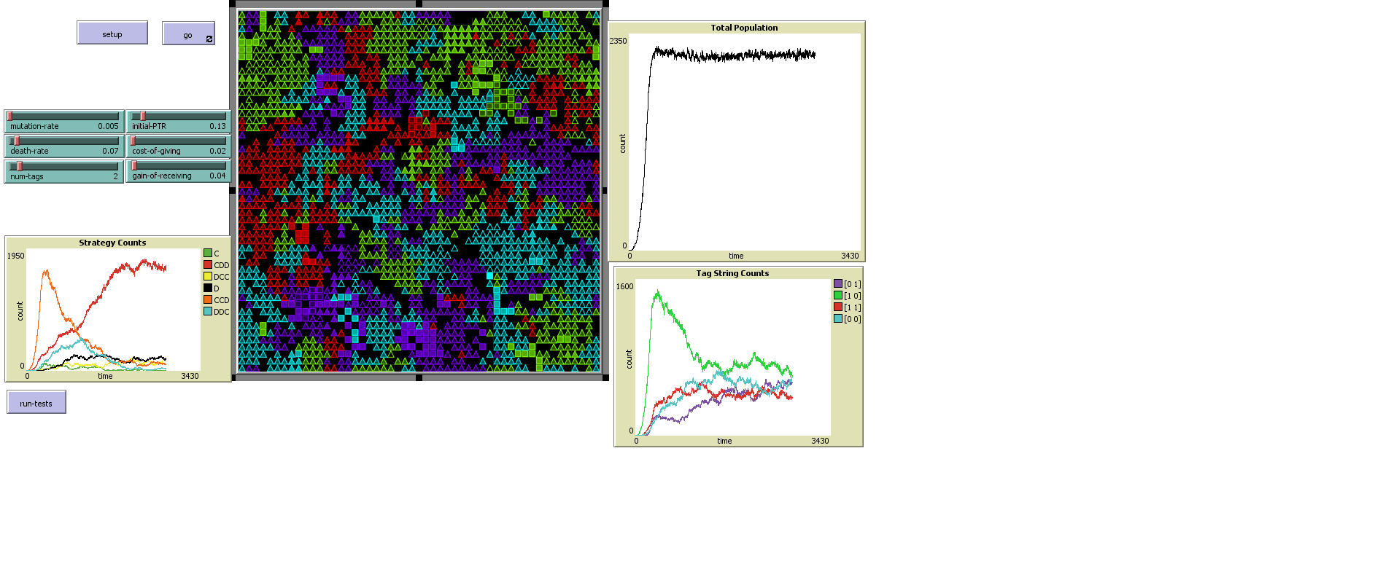

Here we are using hue to represent similarity and differences. The tag strings [1 1] and [0 0] are represented by the complementary colors red and cyan. Likewise [1 0] and [0 1] are represented by the complementary colors lime and magenta, which highlights the similarities between similar tag strings using colors. We have re-labeled the strategies here and added two new ones. The “C” strategy indicates always cooperating, the “D” strategy always defects. “CDD” will cooperate only with an agent that matches its tag string exactly, while “DCC” will defect only with an agent that matches its tag string exactly. “CCD” will cooperate with an agent that shares at least one tag in common with it, while “DDC” will defect with an agent that shares at least one tag in common with it. We do still see a strong preference here for a purely ethnocentric strategy. The initially dominant strategy appears to be dependent on whichever strategy was present in the initial population.

I suspect also that the small size of the world is causing agent populations to run into each other very quickly, and other strategies might dominate if different populations were given more room to develop. To test this, I will make the world larger, and create multiple starting agents. In an example run here, I have restored Axelrod and Hammond’s original parameters for low cooperation with no tags. Though we created 30 starting agents, only 2 initial populations survived. Initially, we see a strong growth in pure cooperation, followed by a rise in partial ethnocentrism with CCD. This seems to run counter to the idea that competition fosters cooperation, however I suspect the mutation rate is too high for significant group selection to occur between separate populations. Note that there is a certain striation of coloring here. Completely different groups do not live near each other, but have other, partly similar groups between them.

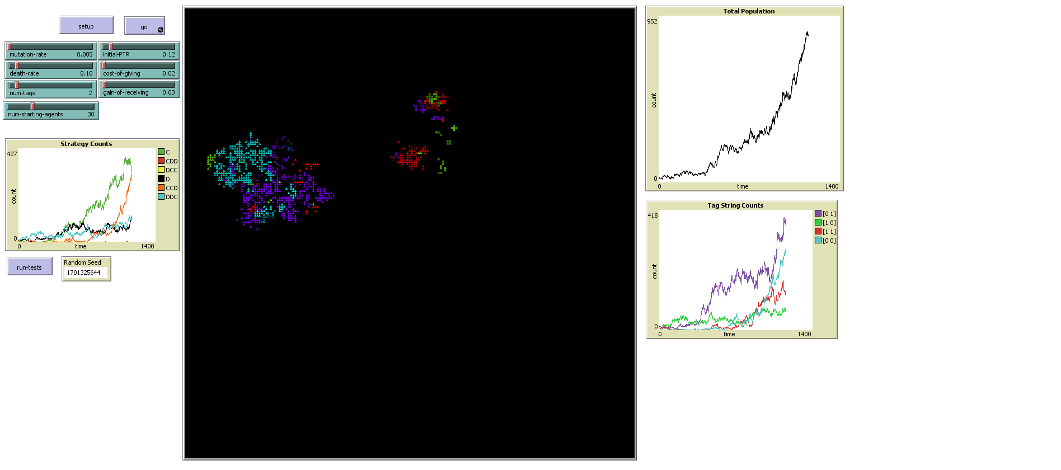

As the populations continue to grow, they eventually run into each other. It is around this time, as space becomes scarcer, that we see a rise in pure ethnocentrism with CDD:

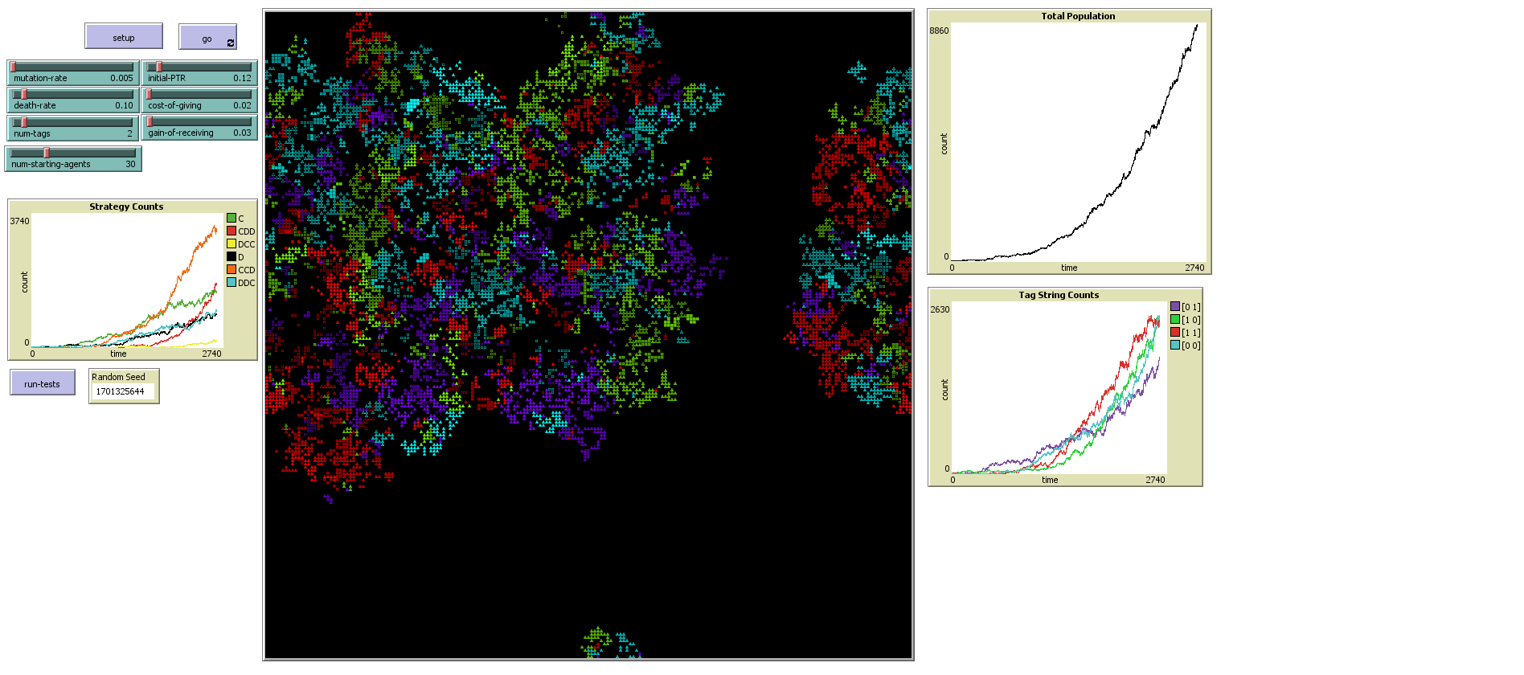

Note that we also see more instances of groups of colors directly abutting their opposites. This is an interesting outcome. With “CCD,” a single tag similarity fosters cooperation between the groups and not with opposite groups. With “CDD,” the behavior is the same for any different color—they will always defect. The extent to which different groups abutting each other causes greater ethnocentrism, or if greater ethnocentrism to some extent facilitates very different groups living near each other is not immediately clear and warrants further examination.

As the population continues to grow, we see a further rise in pure ethnocentrism and eventual decline in partial ethnocentrism:

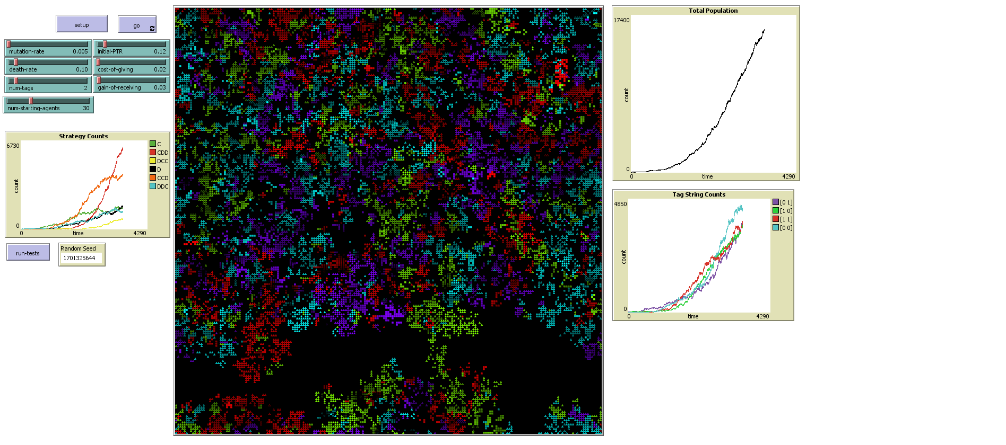

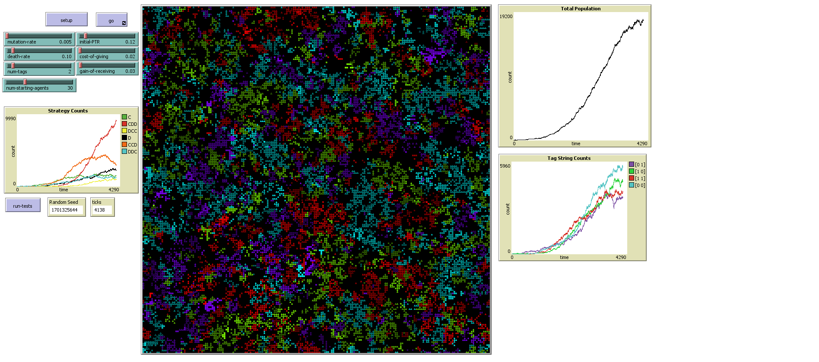

It’s worth exploring the effect of changing parameters. For example, if I reduce the cost of cooperation (these are now the parameters used through most of Axelrod and Hammond’s model):

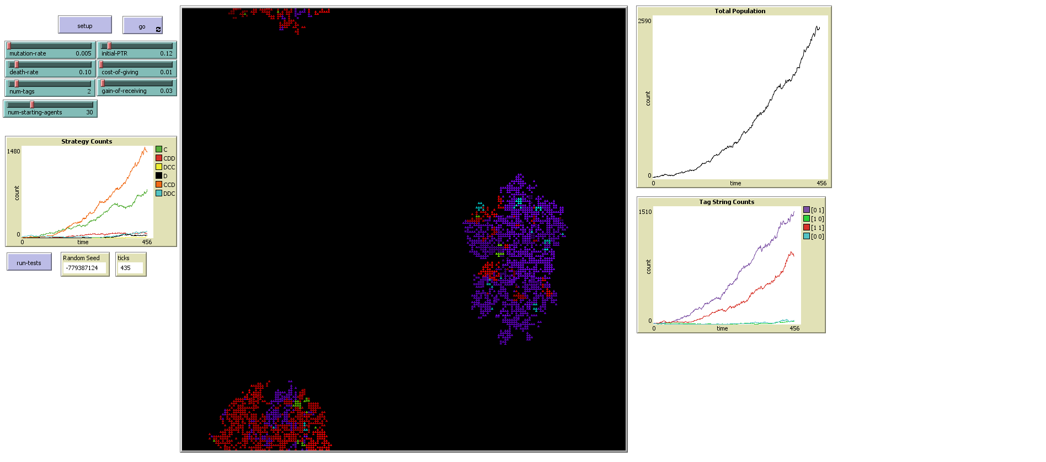

Here we see two populations that grow very rapidly, and a much stronger early rise in CCD, although the extent to which this is based on initial random conditions is unclear. We also see similar color striation patterns than before, though here, the population seems much more homogeneous and less diverse than before.

As the populations grow, they begin to become more diverse. Cooperation continues to remain strong:

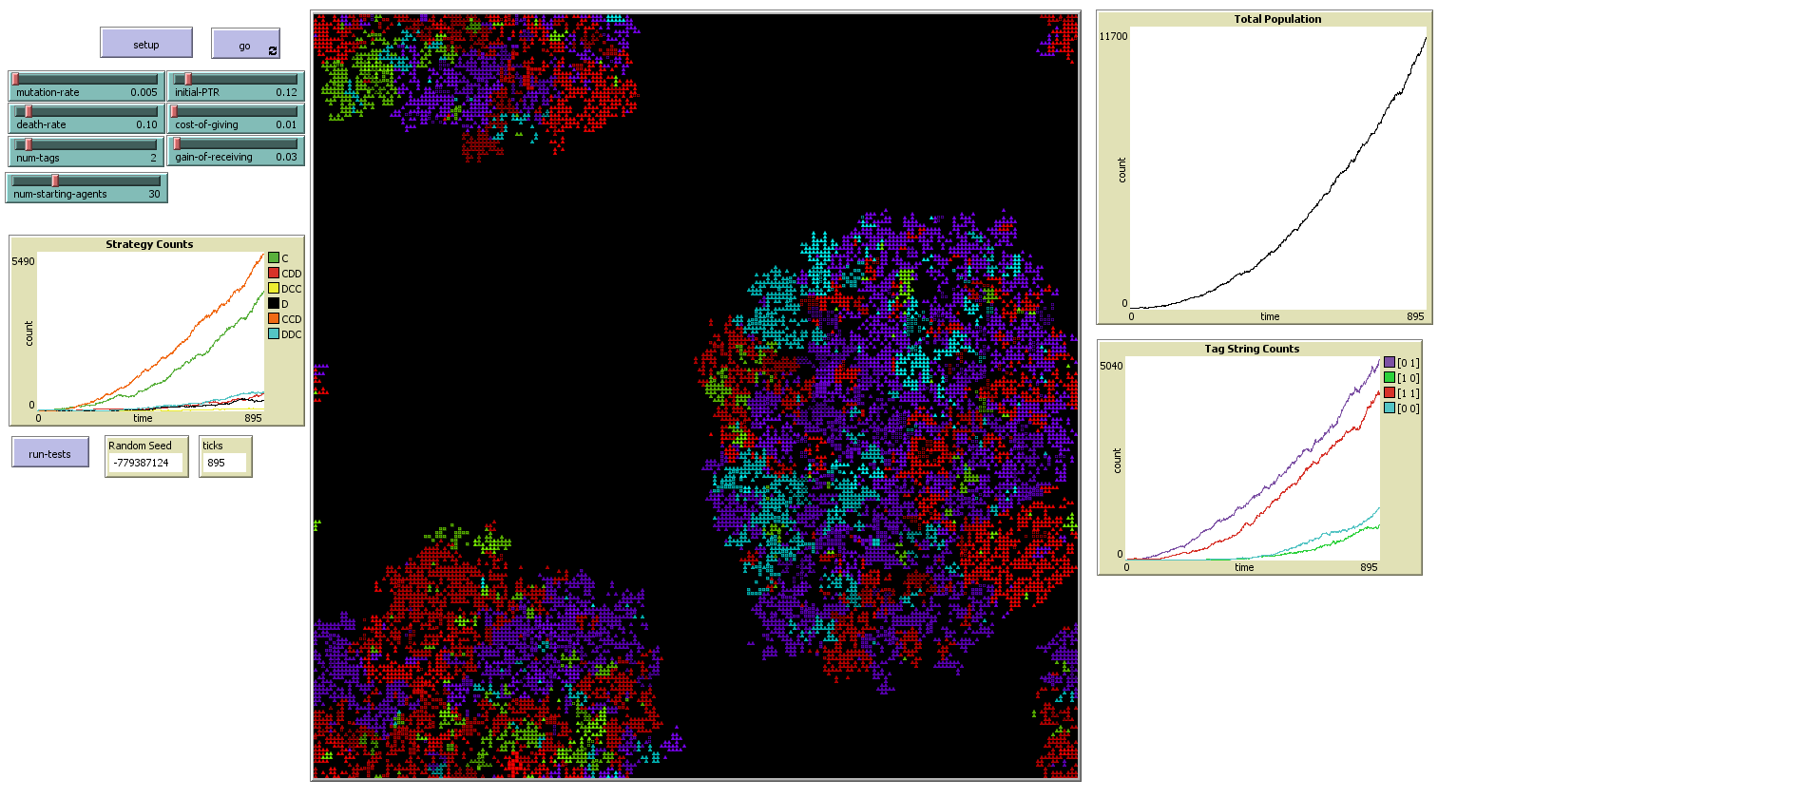

As the populations begin to grow into each other, cooperation continues to be strong for a time:

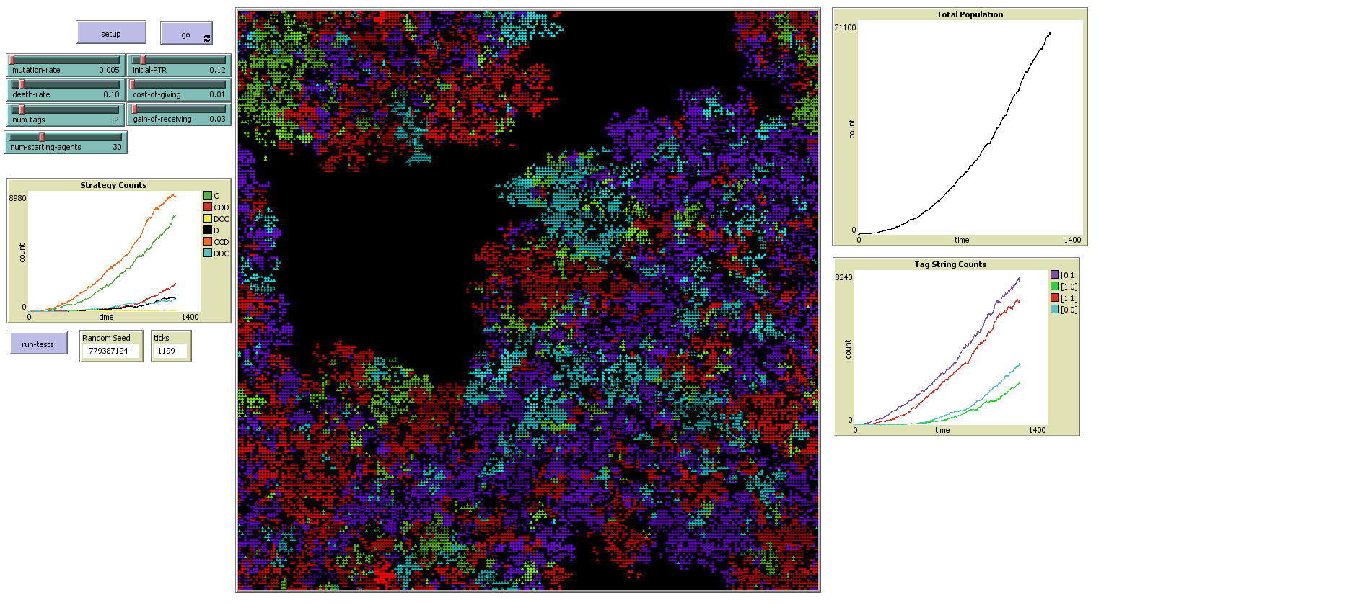

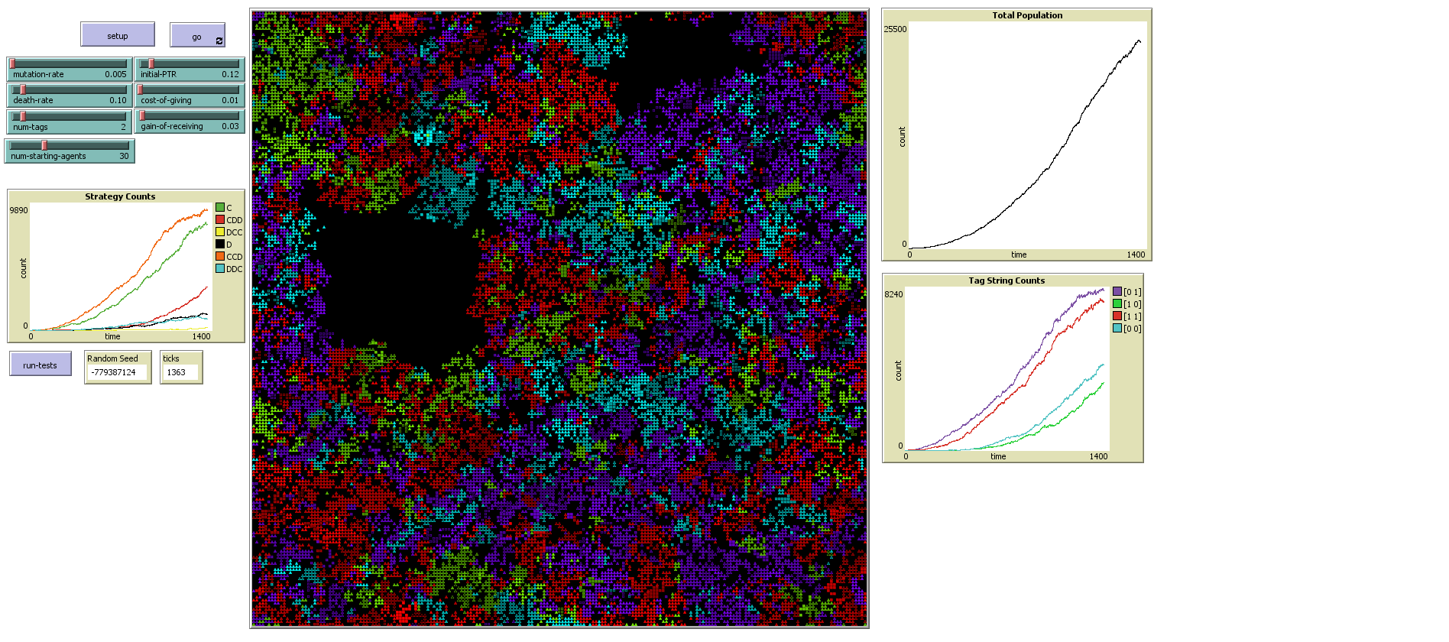

We see here though that pure ethnocentrism is beginning to emerge. As space becomes scarcer, populations are eventually forced to become more competitive:

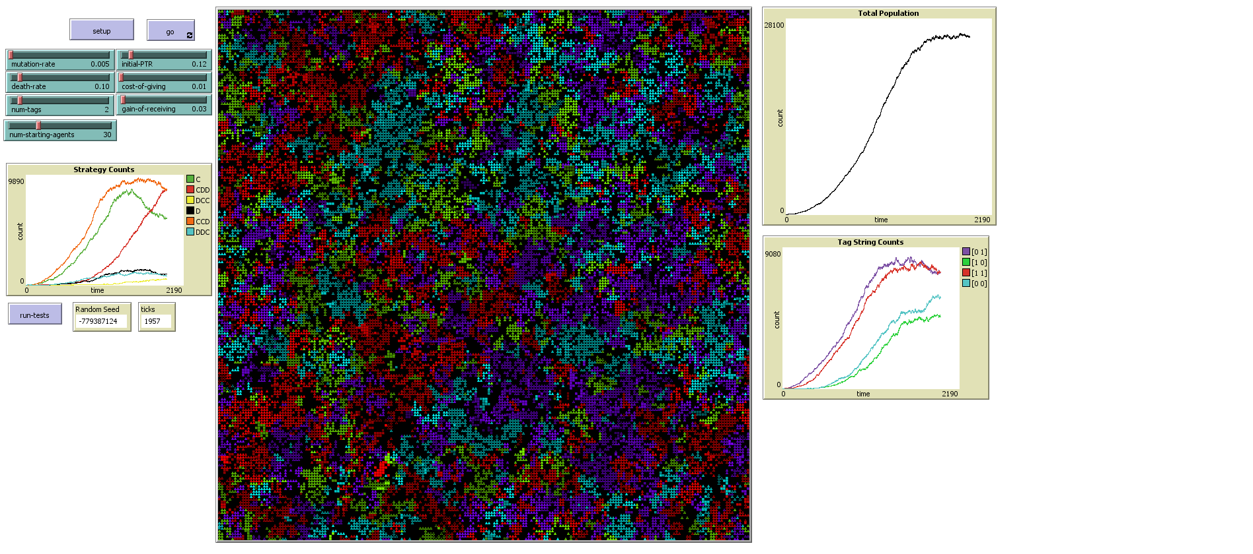

We see here a sharp rise in pure ethnocentrism accompanied by a sharp decline in pure cooperation and an initially more modest decline in partial ethnocentrism. As time passes and there is no longer room for expansion, this trend continues:

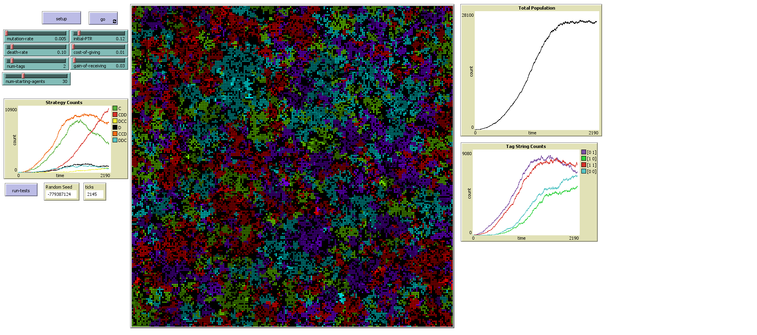

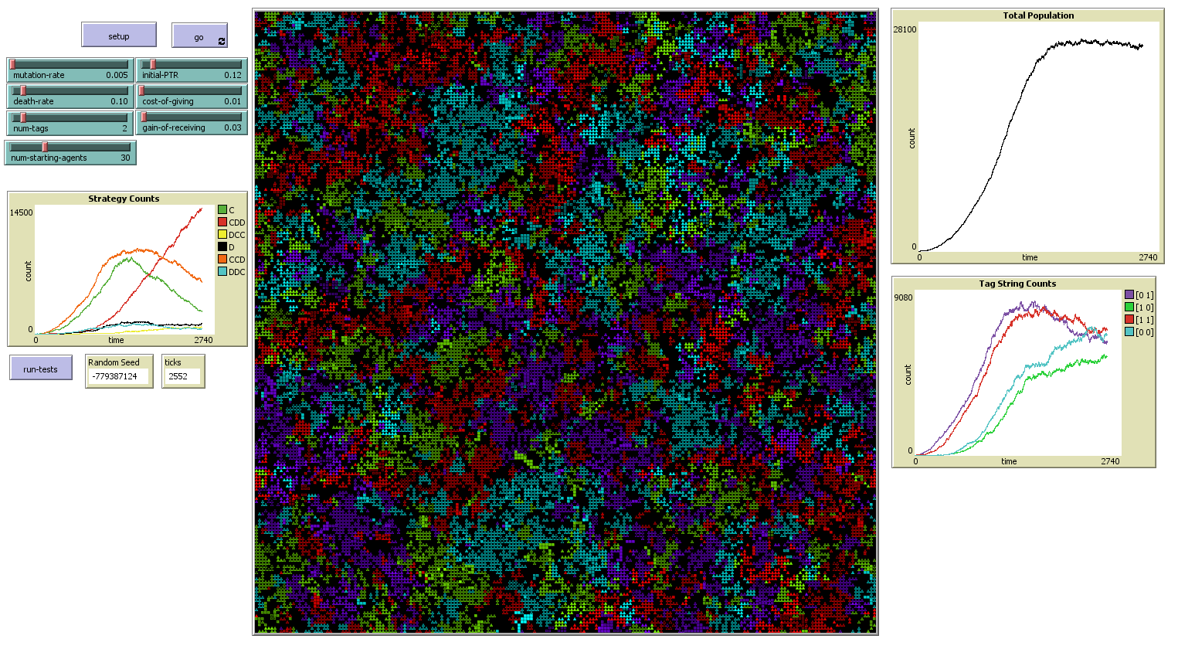

By this point, the total population has remained constant for nearly half the run—this space has reached its carrying capacity. Pure ethnocentrism is now becoming the rule, and any more cosmopolitan strategies are being stamped out. We can easily see this trend continuing as the model goes on, with insular ethnocentrism becoming the dominant ideal:

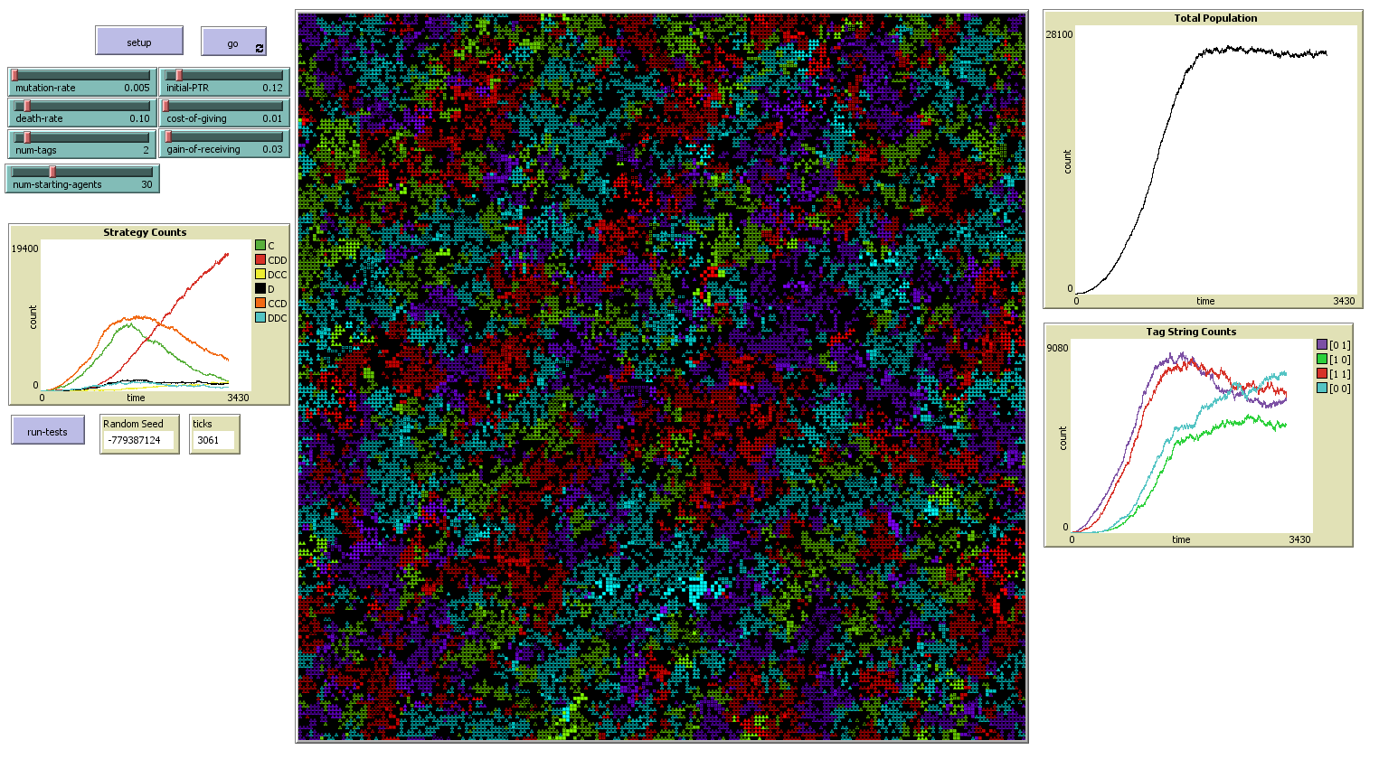

Note that because of the larger world, there is much less variation over time in the prominence of individual strategies or color populations, as fluctuations in individual subgroups contribute much less to the overall total.

It is worth examining the parameters I originally set that produced much more cooperation in the 1-tag case than in 0-tag case, and seeing how they do with two tags in this large world.

The first thing we note is that, because of the larger difference between initial-ptr and death-rate, many more populations survive. We also see a strong surge in cooperation. This early in the simulation, this is less likely to be an effect of selection than of the reproductive benefits of cooperation within a population. And indeed, we can observe several large populations of cooperators quickly forming:

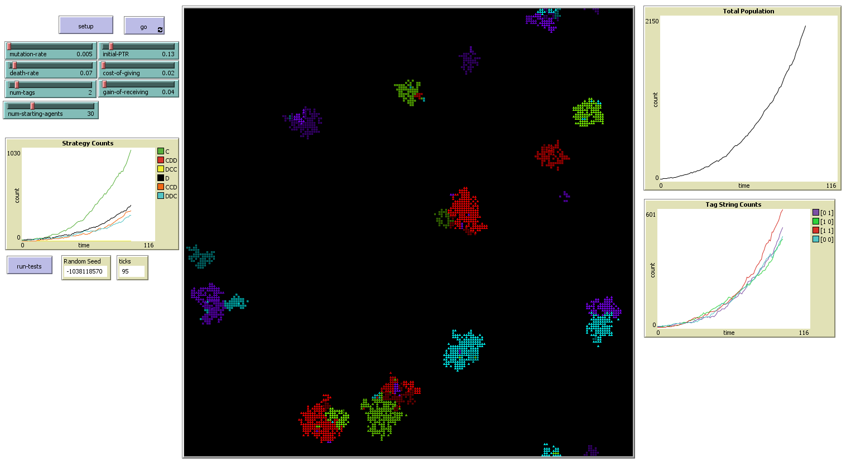

Even as groups begin to grow into each other, cooperation still remains a dominant strategy:

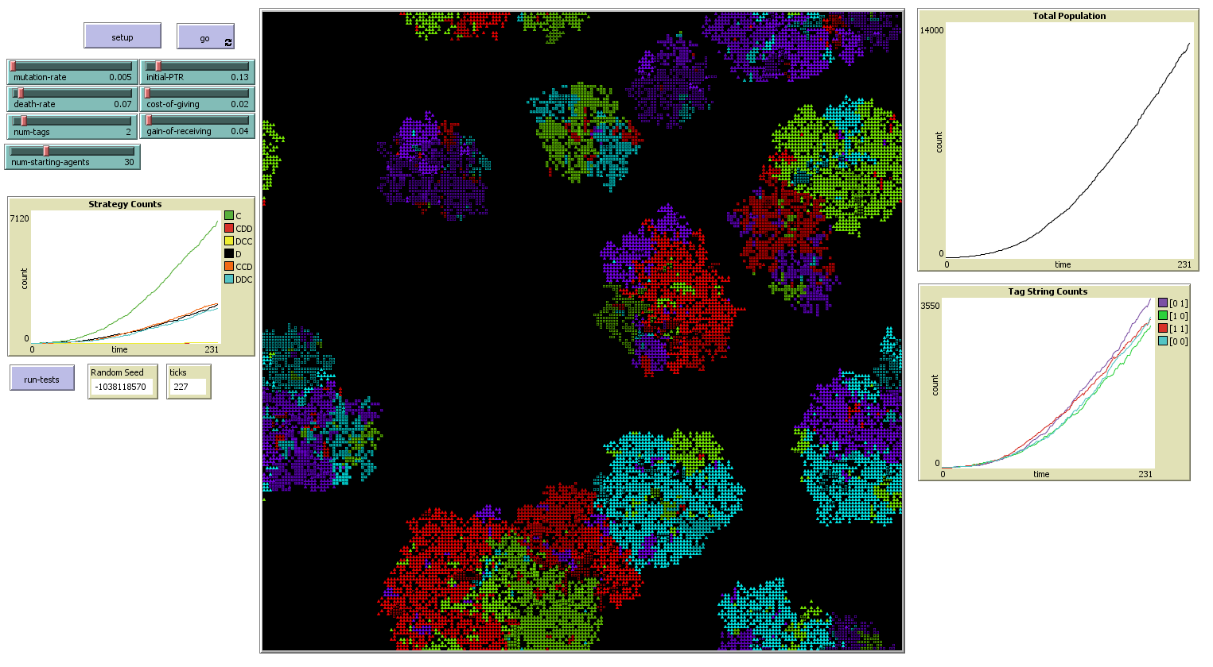

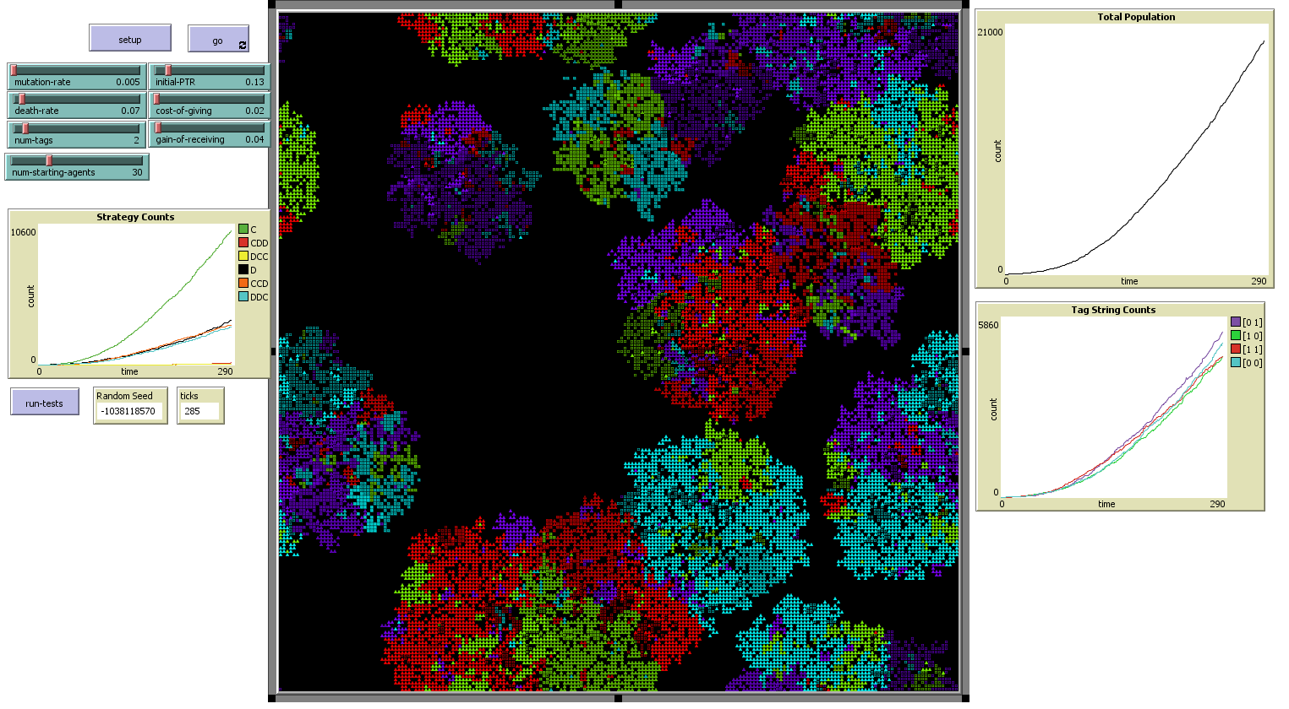

As space begins to become scarce, we begin to see a rise in discontents. The growth of pure cooperation begins to round off together with total population growth, we see a rise in egoists who do not cooperate at all, and pure ethnocentrism, which had been virtually nonexistent before, now begins to be visible in a small minority:

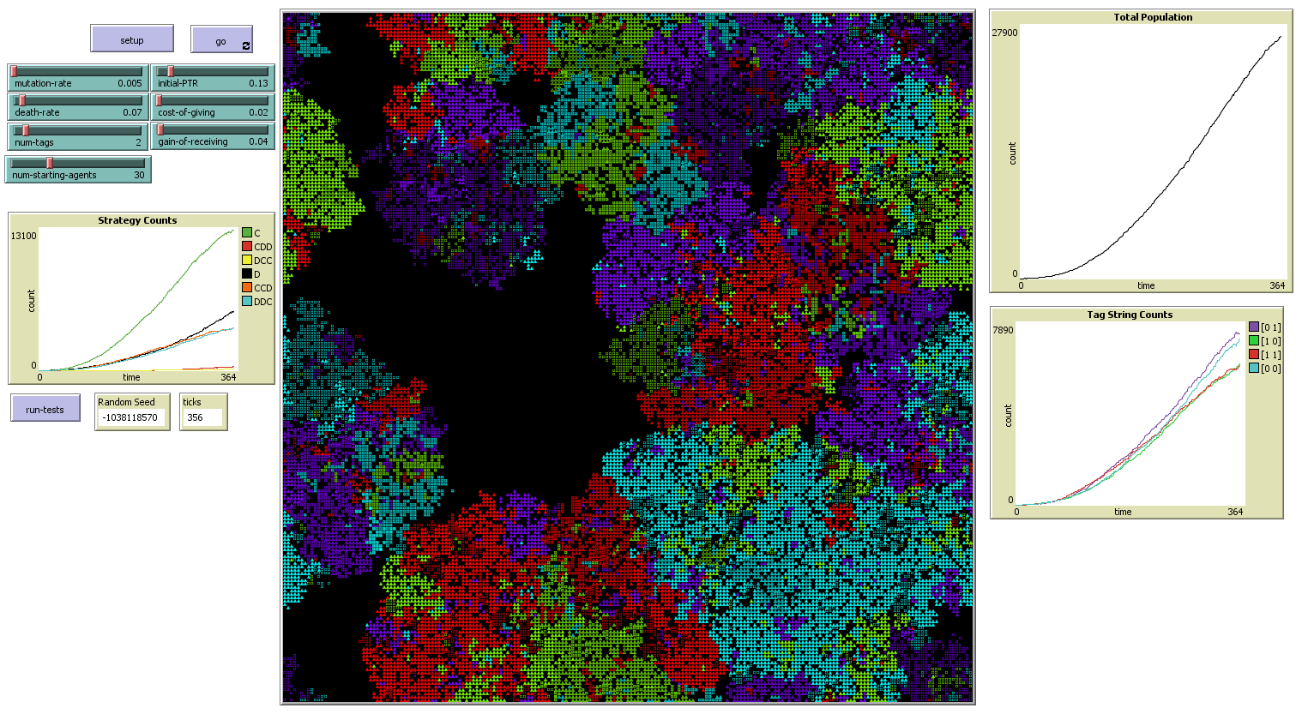

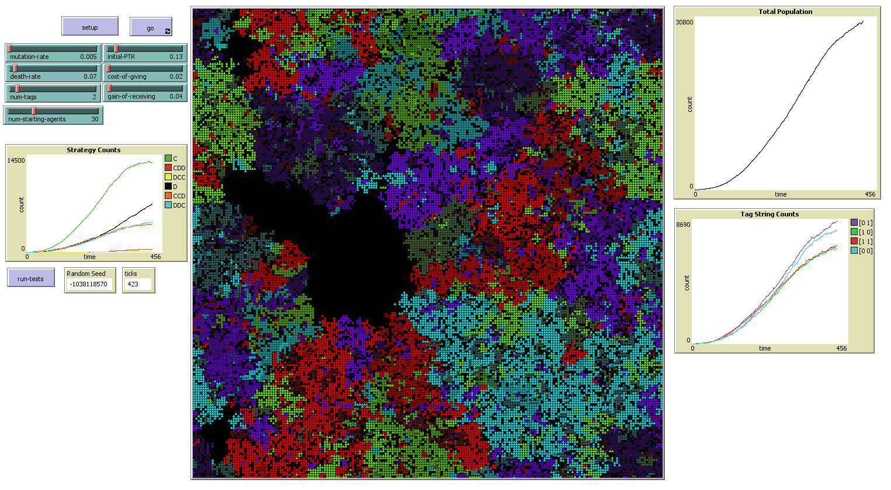

What we see at this point differs markedly from the 1-tag case and more closely resembles the 0-tag case. Cooperation is declining, but it is not being replaced with ethnocentrism, but with egoism. Ethnocentrism exists, but in a much smaller fraction of the population, while egoism begins strong growth. This also differs from what we had observed with these same parameters in a smaller world. This suggests that the scarcity of space is actually one of the main driving factors against cooperation, as when space was plentiful, populations that cooperated with each other did much better, and it is only as space begins to become scarce that cooperation declines:

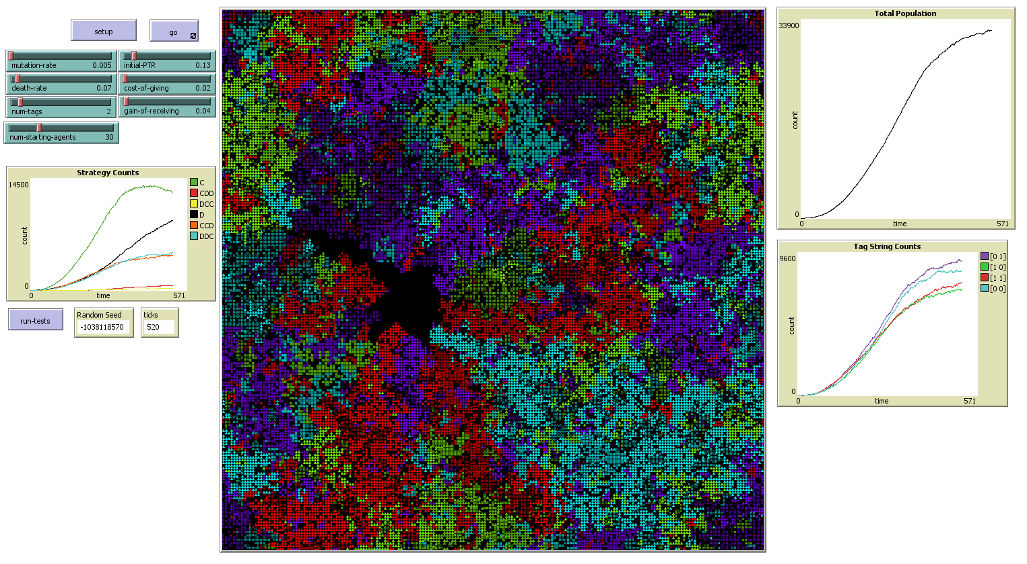

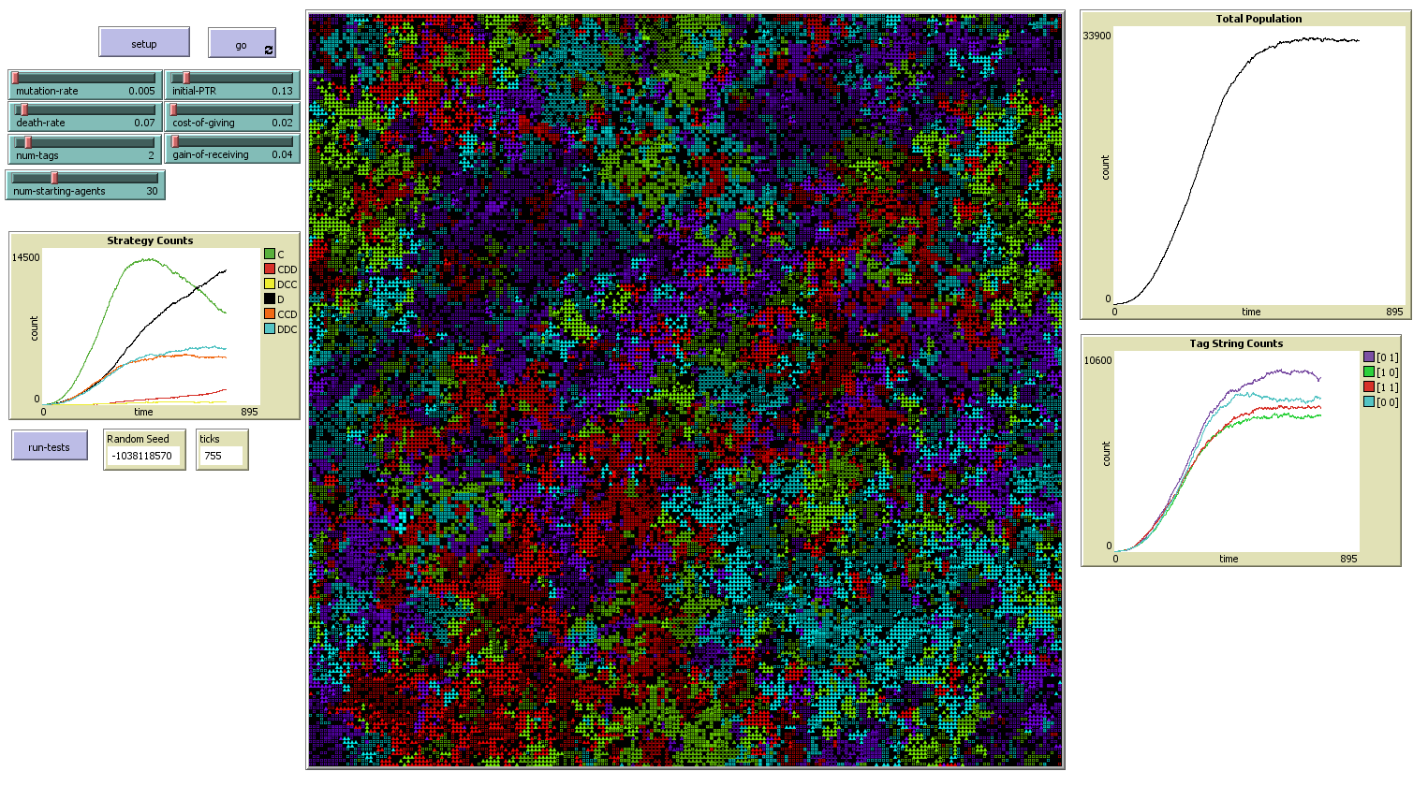

At this point, the world has reached its carrying capacity, which you will note is larger than in previous runs due to the lower death rate and higher reproduction rate. The total size of this world is 201x201 patches, meaning it could theoretically support up to 40,401 agents. That the carrying capacity of the space is less than this emerges from the natural cycle of death and reproduction.

As time passes further, and the population has reached equilibrium, now is when we begin to see pure ethnocentrism gain a foothold. Partial ethnocentrism never had an exceptionally strong presence, but now that the system is at its limits, agents are searching more carefully for better reproduction strategies, and it seems that pure ethnocentrism is the best choice for overall population survival:

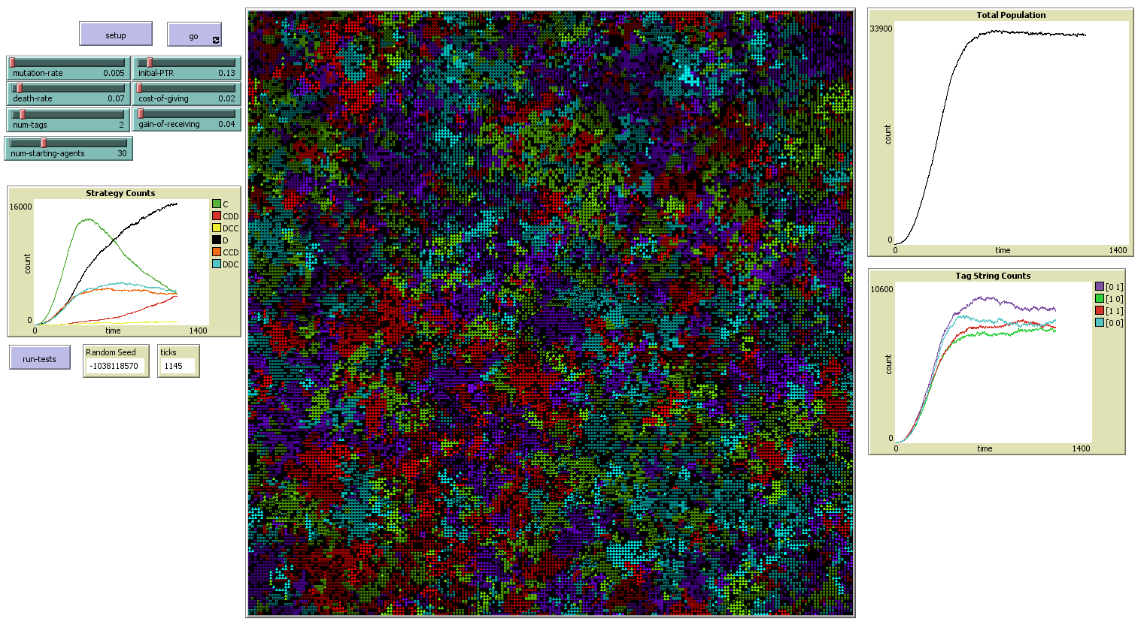

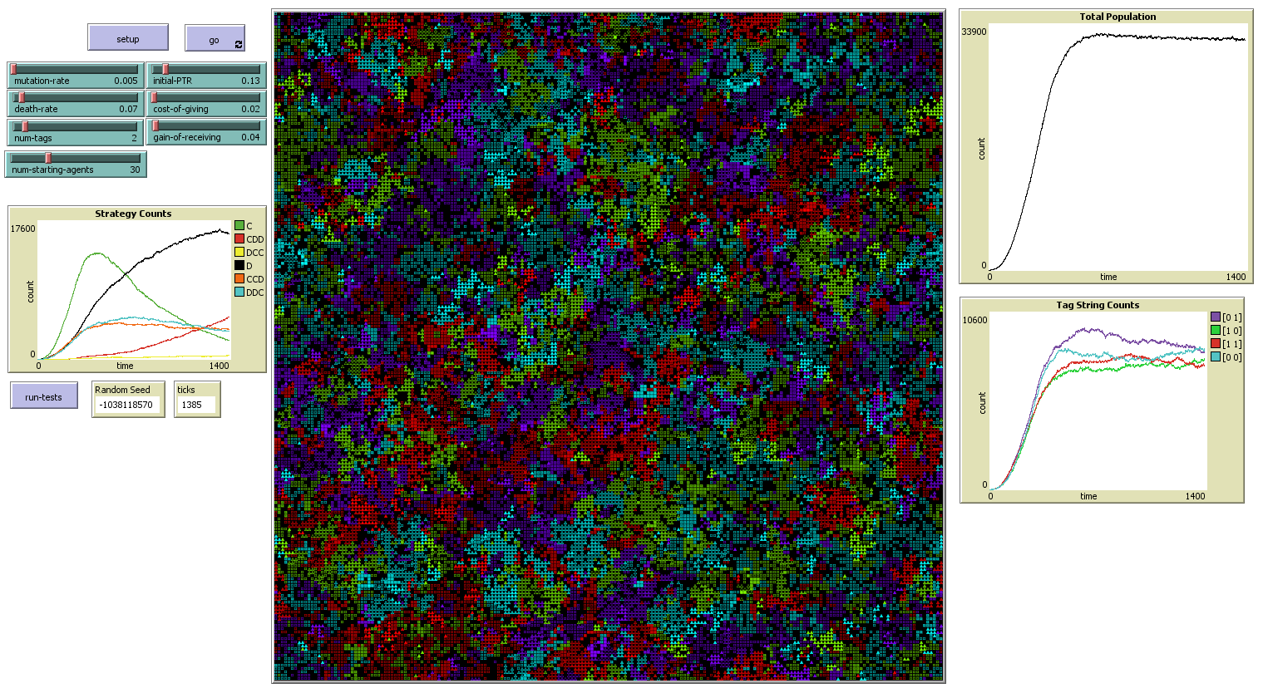

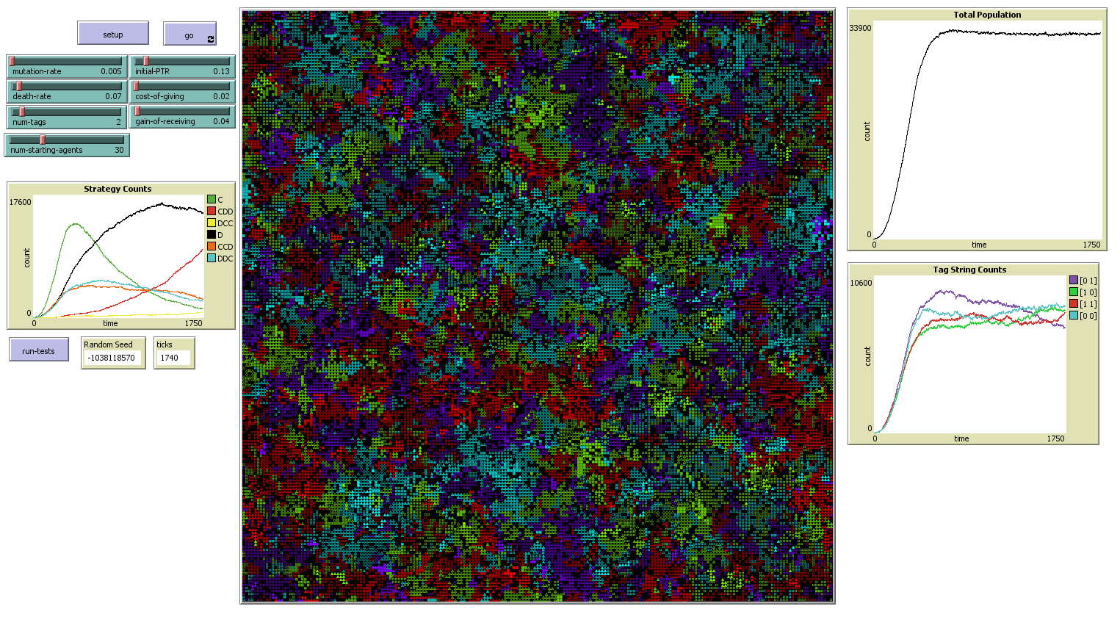

Eventually we see ethnocentrism overtake and replace egoism:

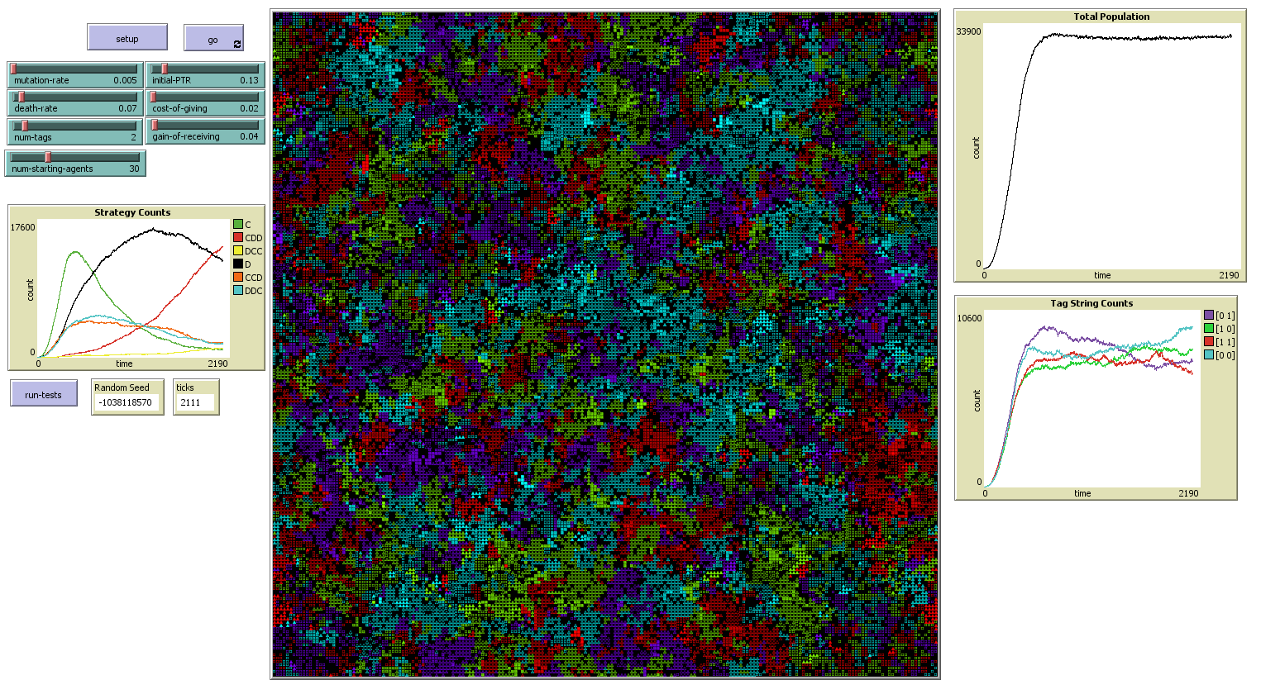

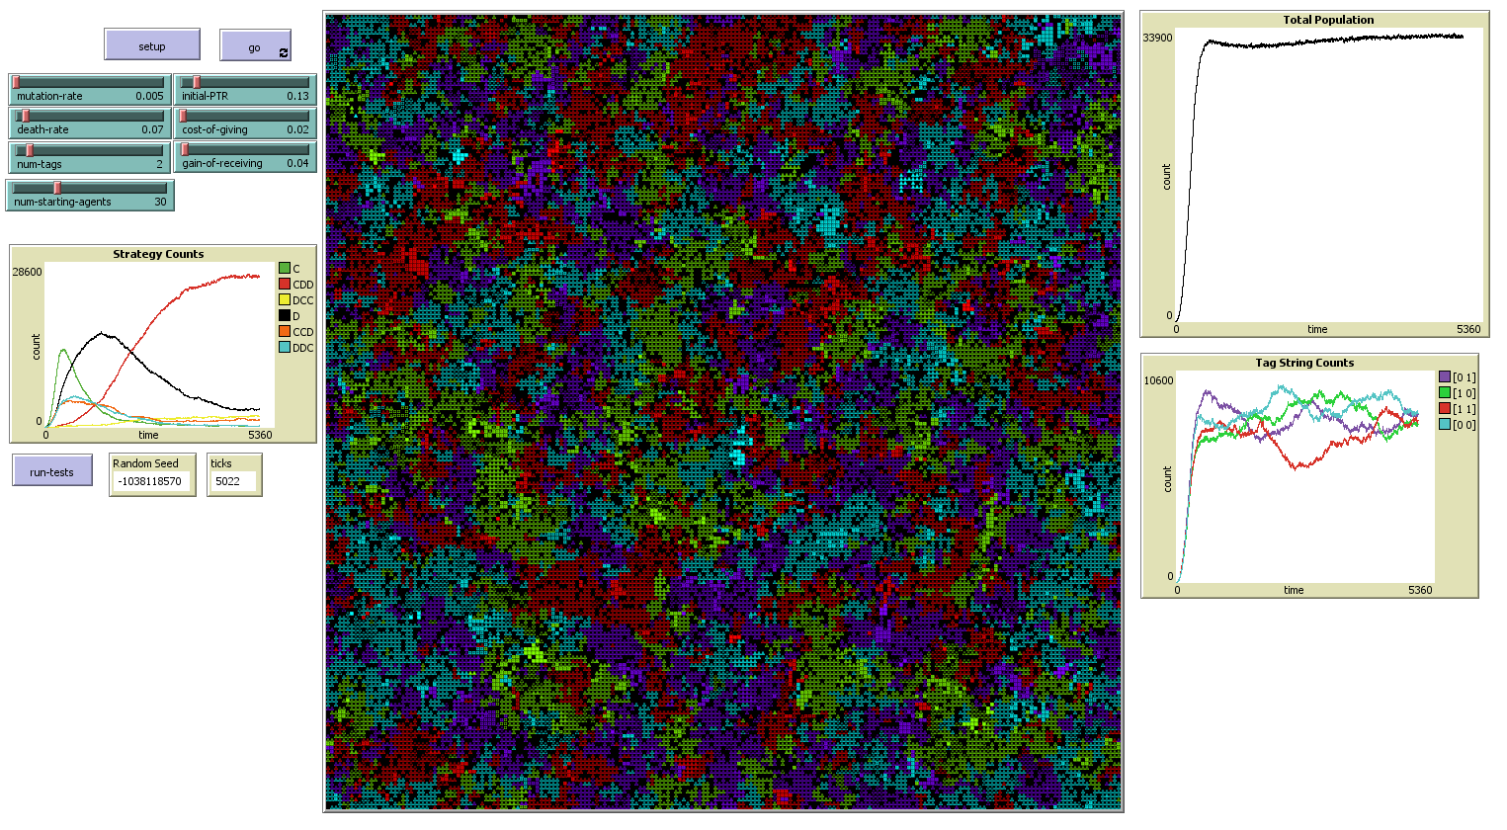

After an initial surge in cooperation, followed by a temporary wave of egoism, the system seems to have reached its steady state with ethnocentrism. It is easy to see why egoism became the dominant strategy in the 0-tag case, as there were no other colors to be ethnocentric towards. Note in the image above that the more brightly colored patches indicate agents more inclined to cooperate with outsiders. Also note that in most of the population groups, those agents tend to be clustered in the middle of their own group while the agents near the edge are more ethnocentric. This is also a result that Axelrod and Hammond observed. We see here the greatest tolerance for other colors in those agents that have the fewest interactions with other colors.

Above, I wondered to what extent mutation drove the phenomena we observed, and to what extent it might inhibit group selection. I will now examine this by looking at an extreme case where mutation is completely disabled. In this way the only way that populations can “evolve” is by either reproducing or being driven to extinction by their neighbors. How does this affect our results?

At this point, I noticed a slight flaw in my agent creation logic. I was setting different threshold with the command “set different-threshold random num-tags + 2,” because of NetLogo’s byzantine operator precedence rules, it was interpreting this as “set different-threshold (random num-tags) + 2,” rather than my intended “set different-threshold random (num-tags + 2),” meaning that agents could only be created with different-threshold set to 2 or 3. Since this only affected initial creation and other strategies could be quickly mutated into, I do not believe this significantly impacted the outcomes of the runs above. This is also why I did not more closely examine this method in my test code, as this logic was only used in initial setup, and not once the model began running. I have corrected it for this run and ensured that every strategy gets at least some small starting population:

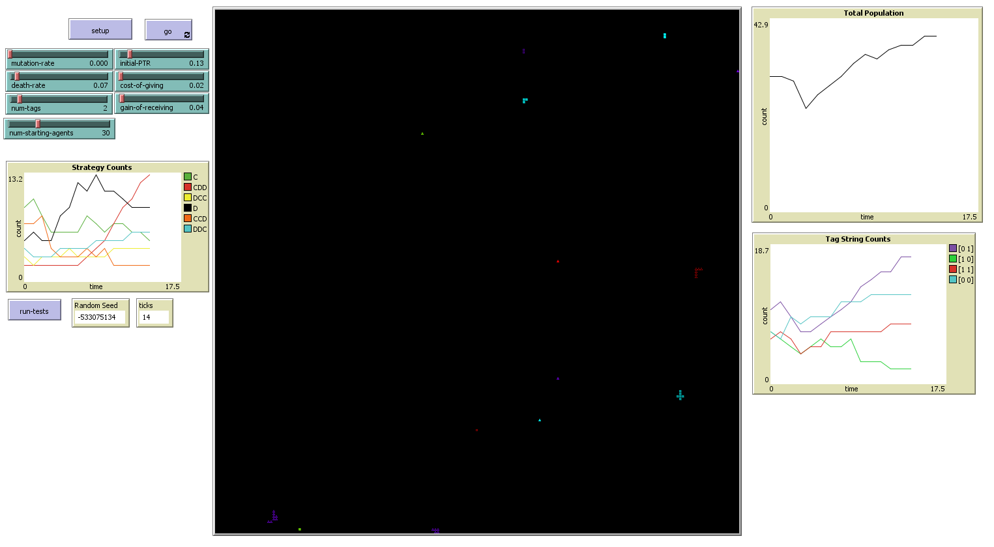

The populations all began an initial rapid expansion, with self-cooperators tending to expand faster:

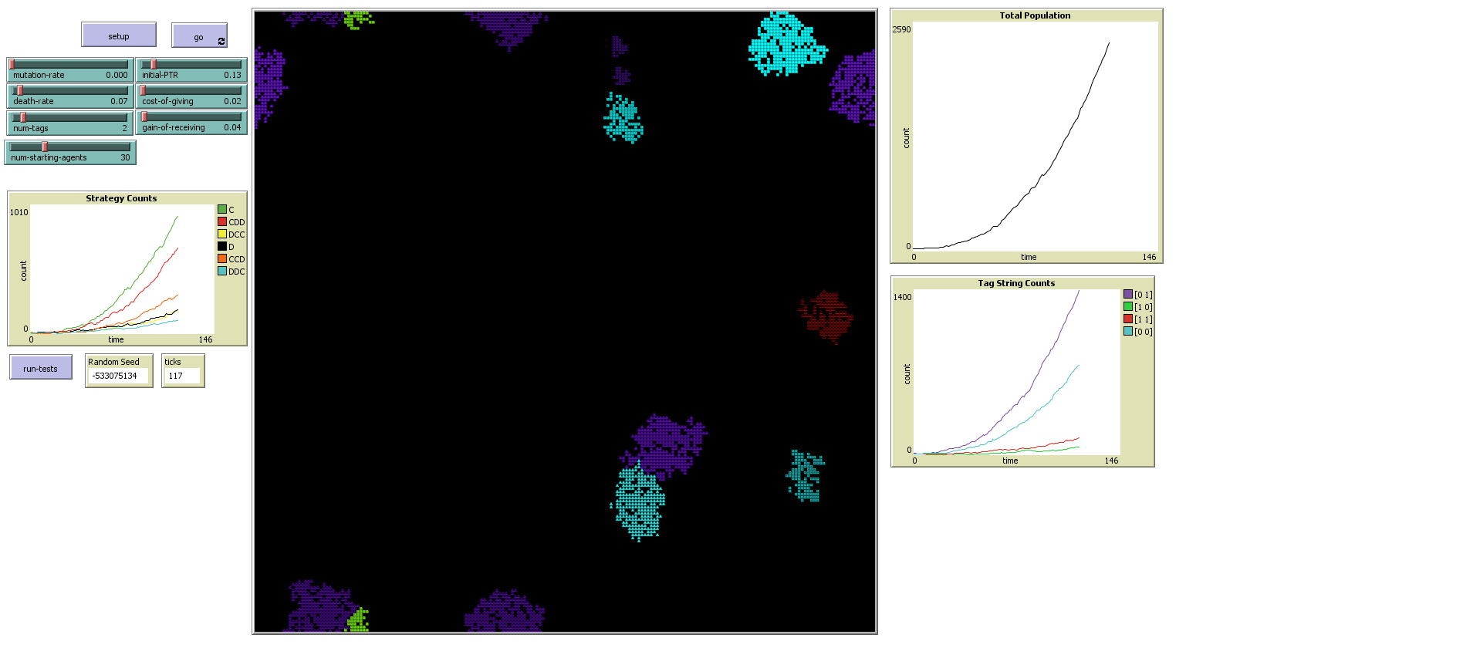

By this point, we can already see populations beginning to run into each other. Near the bottom right, we see a population of purple partial ethnocentrics running against a population of cyan altruists:

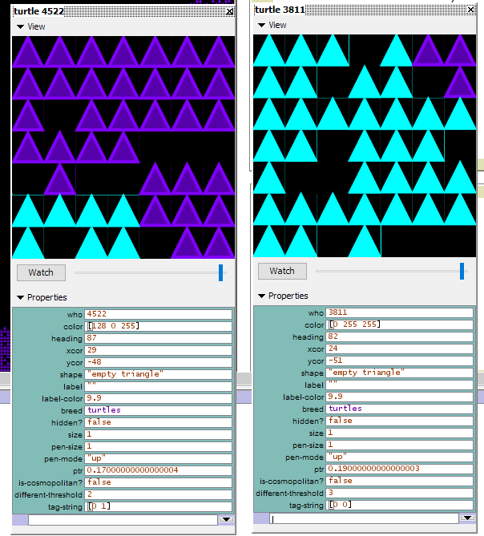

Since they share one tag in common, they will both cooperate with each other and will likely both thrive. It will be interesting to see how the competition for space will impact them.

In the bottom and top left, we see a population of purple pure ethnocentrists running against a population of lime cosmopolitans:

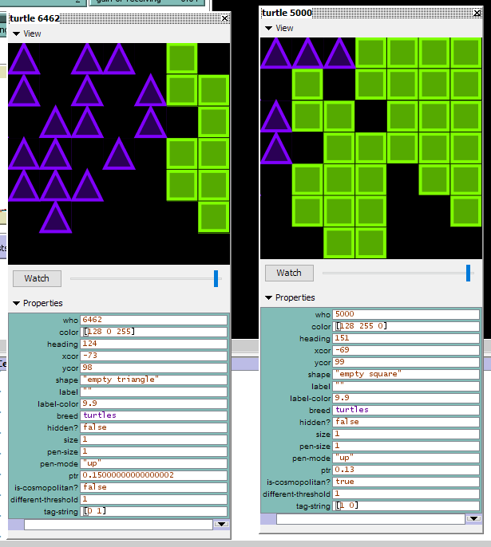

They share no tags in common, so the purples will cooperate with each other but not with the limes, while the limes will not cooperate with each other but will cooperate with the purples. They will be quickly wiped out. It might be interesting to explore a scenario where those not cooperated with still gain some small benefit from the interaction. In this way, they might continue to grow and be exploited by the non-cooperators.

By tick 177, more populations have begun to abut each other:

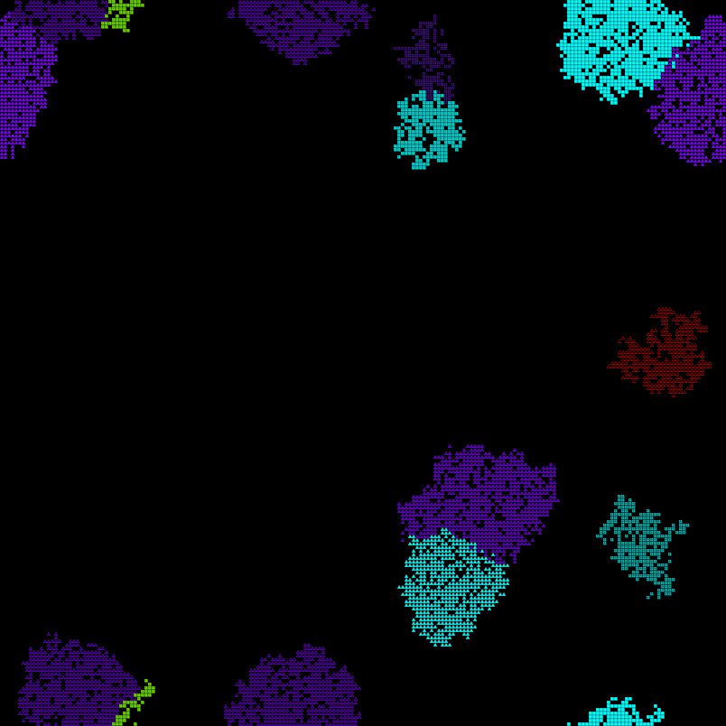

The purple population from before is also abutting another population of purple altruists. We expect that these will cooperate with each other, though it will be interesting to see if the advantage the ethnocentrists gain from the lime cosmopolitans will give them an edge once competition turns fierce. Then again, this population of purple altruists is also abutting a population of Cyan altruists, so they will gain the benefits of cooperation without wiping out their source of it so quickly.

In the top center, we also see a population of purple egoists abutting a population of cyan cosmopolitans:

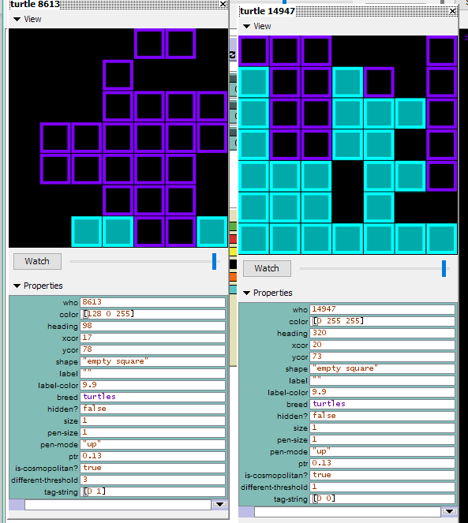

The purple population here will not cooperate with anyone, while the cyan population will only cooperate with the purples, giving the purples an advantage.

By tick 311, the populations with self-cooperation have grown much more rapidly than those without it:

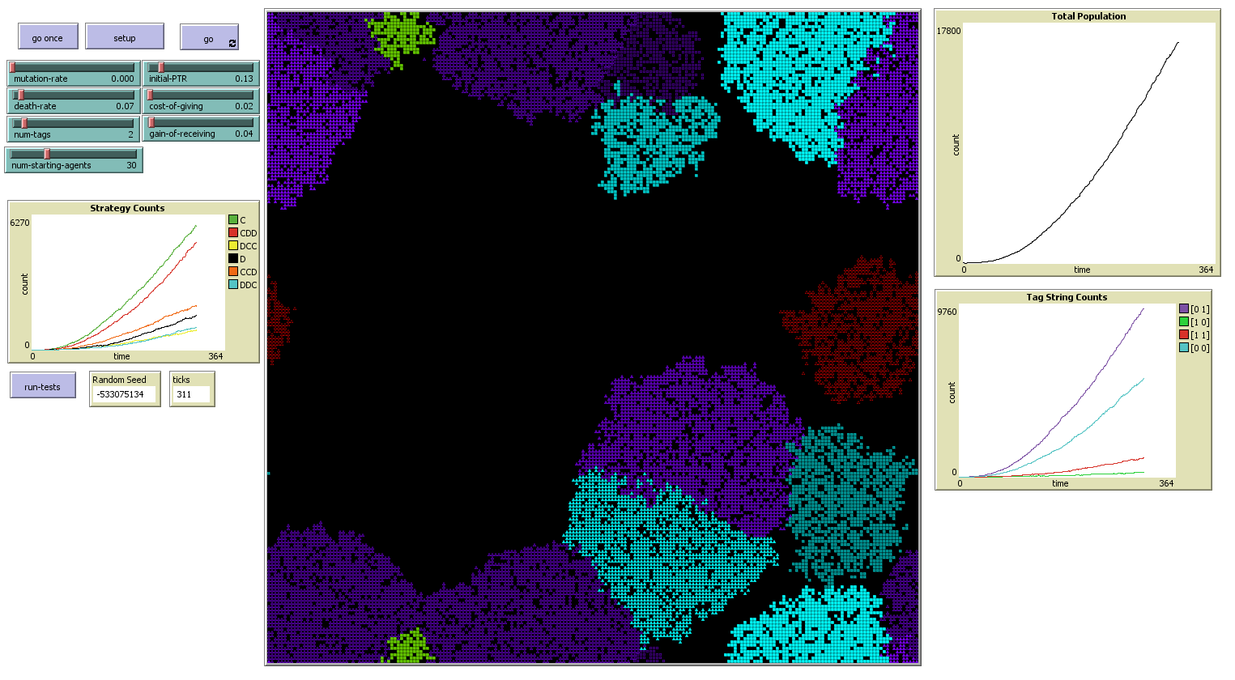

Here the population of purple ethnocentrics in the top and bottom left is merging with a second population of purple ethnocentrics in the top and bottom center and has almost totally surrounded the lime population. This population is also running into the purple egoists in the top center, which it will help, but which will not help it, and with the cyan altruists in the bottom center, which will help it, but which it will not help. There is also in the bottom right, a population of cyan pure cosmopolitans. This population will not cooperate with any of the populations it is currently in contact with but may cooperate with the red egoists in the center right, which so far have not had contact with any other agents.

By tick 385, the lime population is almost totally surrounded by purple egoists and is being very quickly devoured by them. Their decline in population has become quite rapid:

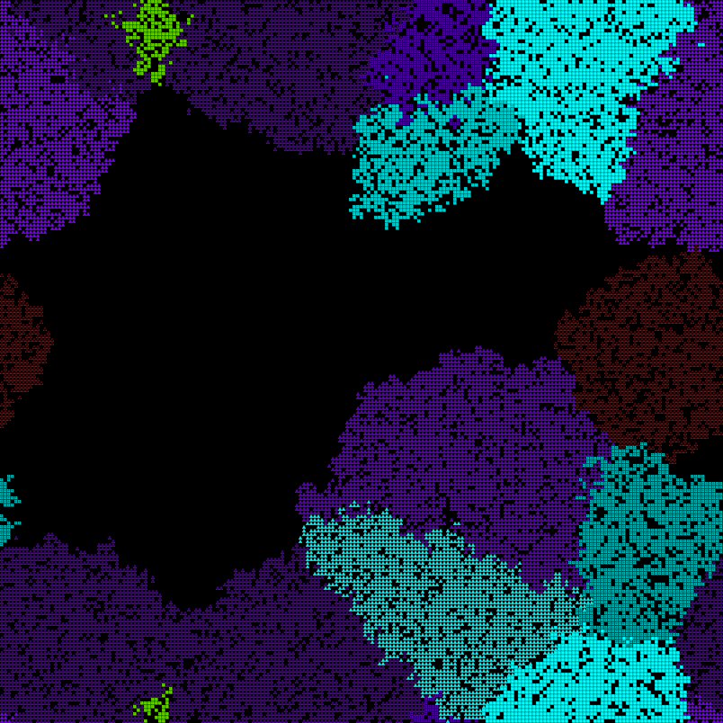

By tick 445 no one is isolated, and every population is enjoying some measure of success, except for the limes who are rapidly being driven to extinction:

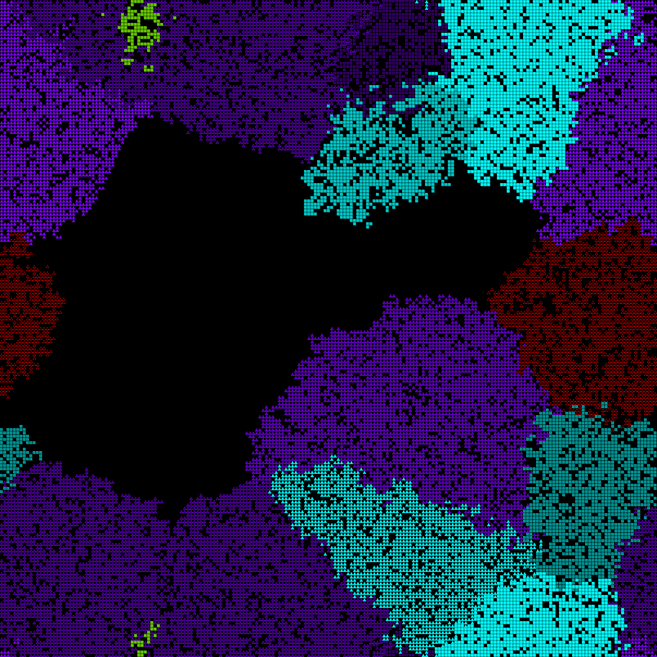

By tick 510, the pure ethnocentrists, which consist entirely of the merged population in the top and bottom left, have outpaced the altruists in growth:

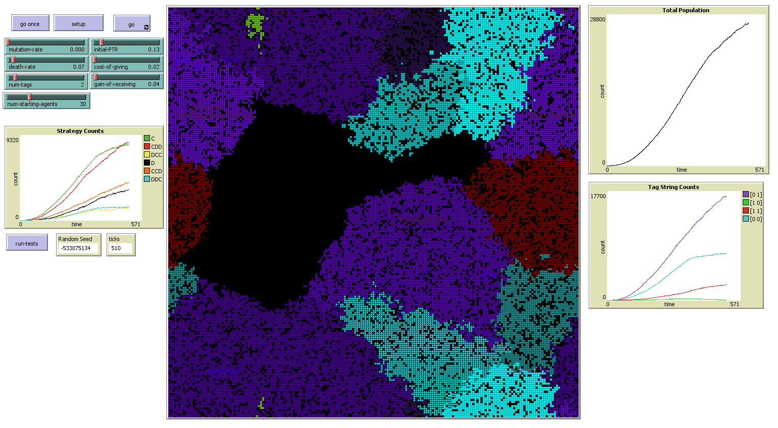

The altruists comprise the merged cyan population in the top and bottom right (the different shapes are an artifact of the visualization algorithm used, but they employ exactly the same algorithm, so should be seen as a single population), and the purple altruists in the top left and right. While the cyan altruists are almost totally hemmed in by the populations around them, the magenta altruists and ethnocentrists both have ample room to expand into the center. It should also be noted that right in the center of the map, with ample room for expansion, are populations of purple partial ethnocentrics (CCD strategy) and cyan partial cosmopolitans (DCC strategy), neither of which has grown very well.

Some of this may be explained by the fact that each of these strategies had only a single starting population, while the pure ethnocentrists had two, it is also the case that the cyan partial cosmopolitans are hindered by their lack of self-cooperation, and the lack of minimizes the diversity of their interactions. They do have a large area of contact with the cyan altruists, but those are the only one of their neighbors who will cooperate with them, even though they do not reciprocate. The purple altruists are also being gradually edged out by the cyan pure altruists (DDC strategy) to their bottom right and the red egoists to their top right, neither of whom will cooperate with them. They do have the large populations of cyan altruists and purple ethnocentrists below them, but in a close border of mutual cooperation, we expect both populations to at best break even, with neither gaining a strong advantage over the other. The pure ethnocentrics however have several populations that they are in contact with whom they can exploit for extra reproductive advantage without having to reciprocate.

There is a definite asymmetry between egoists and several other strategies in the 2-tag model, many more than in the single-tag case. This may explain the surge in egoist population we saw in our last run, and why the egoists are holding out so well against invaders on this run—many other strategies will cooperate with them, but they will never reciprocate. During the initial population surge, self-cooperation ensures rapid expansion, but is not necessary for survival. Once space becomes harder to come by, defectors within a population begin to have a greater advantage, and so edge out simpler cooperation models while still having a significant disadvantage against groups of ethnocentrics.

By tick 623, the lime population is almost totally extinct, with only 5 individuals remaining:

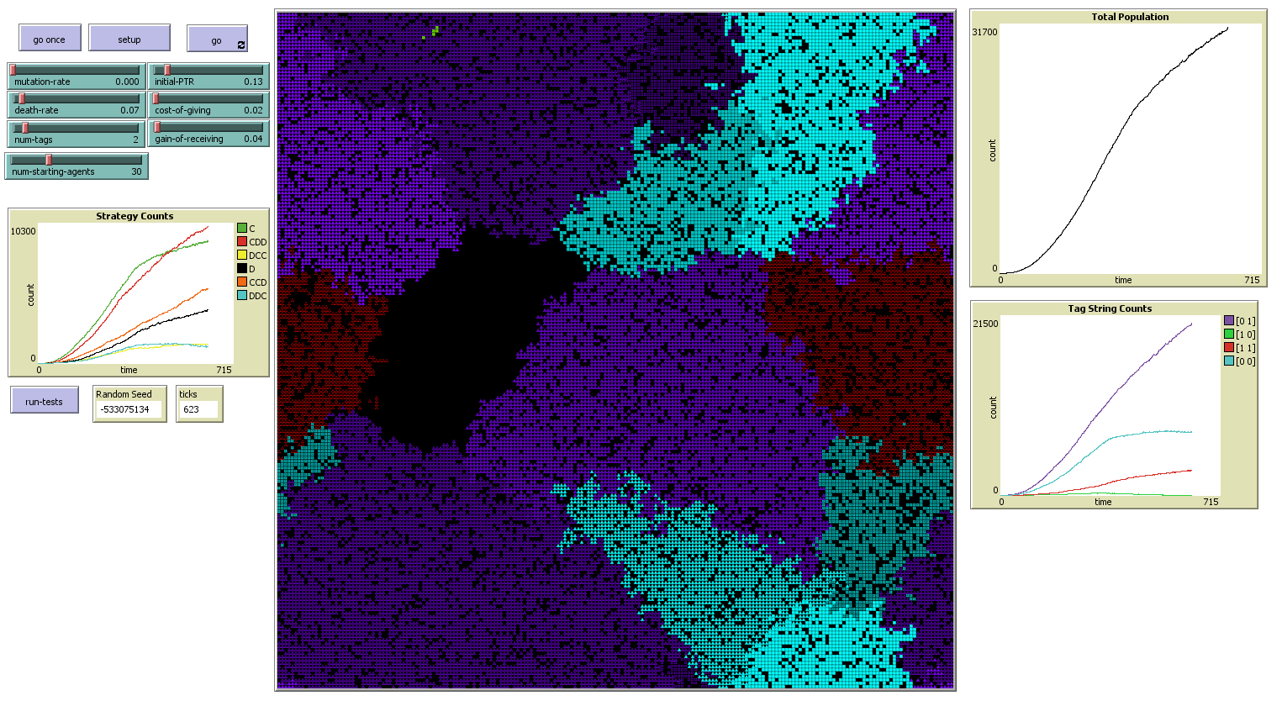

While their DCC strategy never sees much success, it should be noted that the exact same strategy is being employed by the cyan population to the upper right of the center with much better success, so a lot of this is down to bad luck in placement. They were surrounded on two sides by ethnocentrists who rapidly engulfed them, while the other DCC population has roughly 50% of its perimeter covered by cooperators and still has some empty space to expand into. We should also note that the partial ethnocentrism strategy of the center purples continues to grow, though not as quickly as pure ethnocentrism or altruism—though the latter’s growth rate is rapidly declining. Even though the purple altruists have roughly the same amount of room to expand into as the ethnocentrists, the ethnocentrists can also exploit and expand into the areas of the other populations around them, while altruists cannot.

The egoists’ growth rate is also slowing. While the red egoists still have room that they can (slowly) expand into, the purples do not. Both populations however are surrounded by neighbors who will cooperate with them even while they do not reciprocate, which will allow them to gain a slow advantage over them even while they are hindered by their lack of self-cooperation. This is also likely one of the major factors driving the depression of altruist growth, as the egoists have large areas of contact with the two major altruist populations and have been impinging on their territory.

By tick 829, we are out of room to expand into, the limes are completely extinct (it took a lot longer than I expected, really), the center of the map is completely filled with partial ethnocentrics, and the egoists continue to slowly expand into the territory of their neighbors:

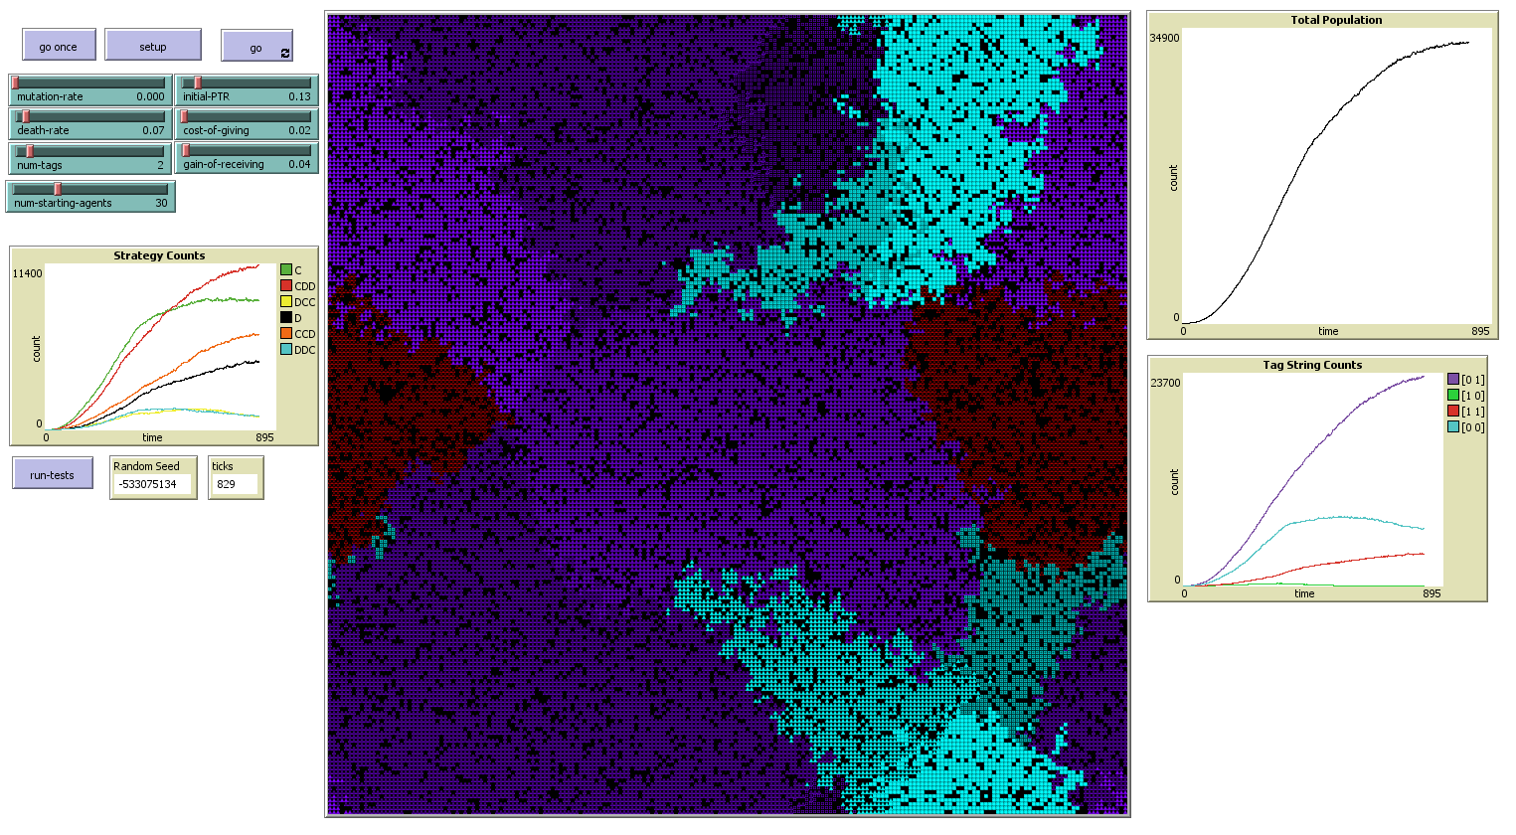

After this, the differing populations seemed to develop into an uneasy balance of power. Altruism continued its decline, while pure ethnocentrism grew, though at rates much more modest than before. Egoism and partial ethnocentrism grew very slowly, and partial ethnocentrism eventually seemed to level off and begin a slow decline. After over 1,000 ticks, the most noticeable change was the precipitous drop in the cyan population, particularly in the lower right corner of the map, where they were being pushed out by the purple ethnocentrists and the red egoists:

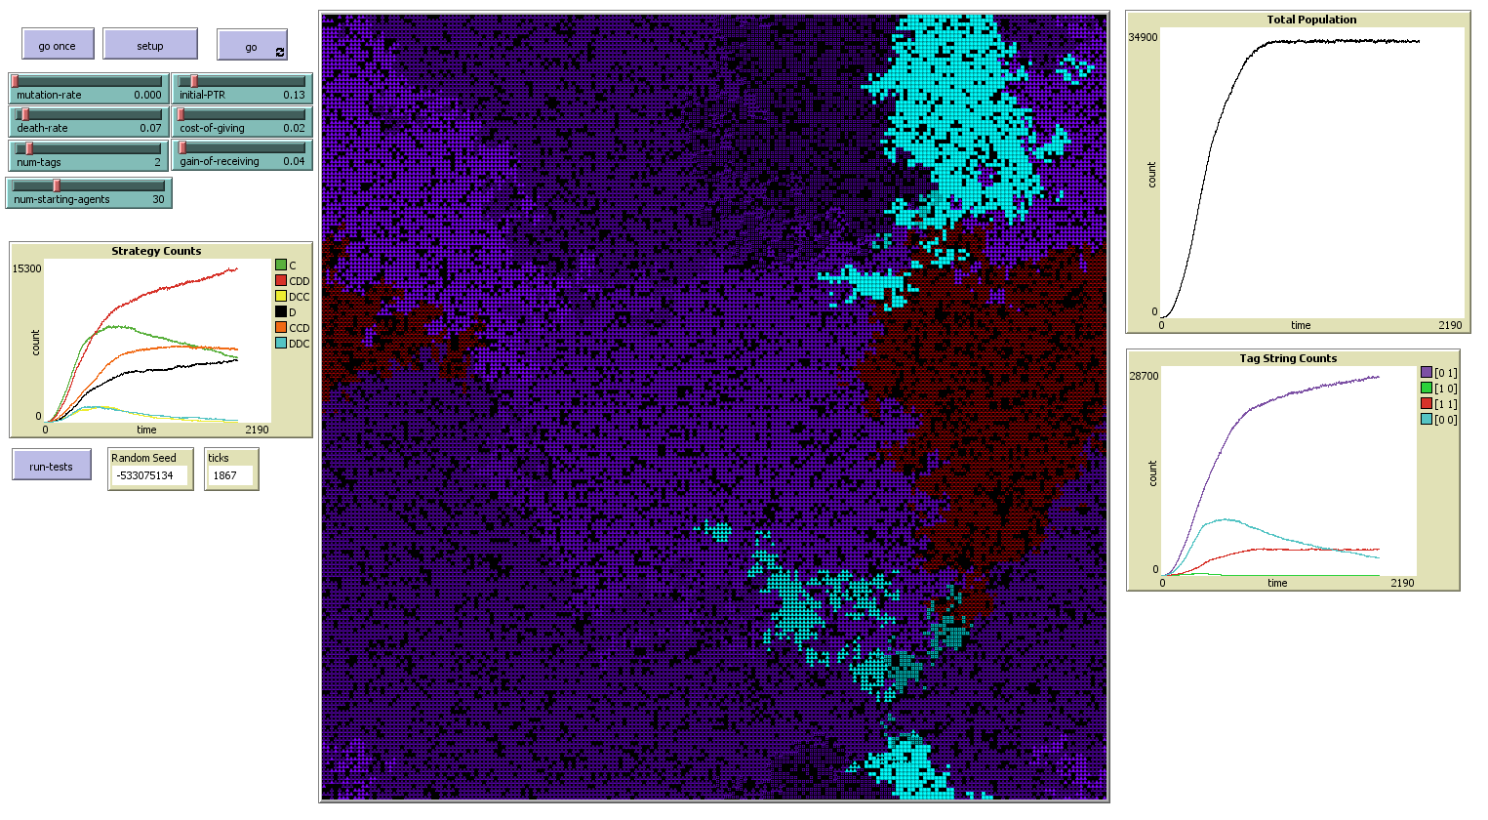

The purple altruists have fared much better, presumably due to being the same color as the major ethnocentrists. Also note that while the shape of the red territory has changed, the total population has been virtually constant. They have expanded some into the territory of those who cooperated with them but have also been expanded into by the pure ethnocentrics to their lower right. In the long term, the purple egoists probably have an advantage over the red ones by virtue of being the same color as the majority ethnocentrist population. The cyans look to be on course to being driven to extinction, while the reds are faring better, at least for the moment. If I ran this model for tens of thousands more ticks, the purples would probably eventually drive the other colors to extinction. With mutation, these parameters, and only a single color, egoism became the dominant strategy, and that may happen here as well. However, the advantage is not as clear-cut without mutation, as the self-cooperators can present a more unified front without having to worry about the development of internal dissent, so whatever happens may take a long time. If nothing else, mutation seems to cause a model to reach equilibrium much faster, as after nearly another 1,000 ticks, very little has changed:

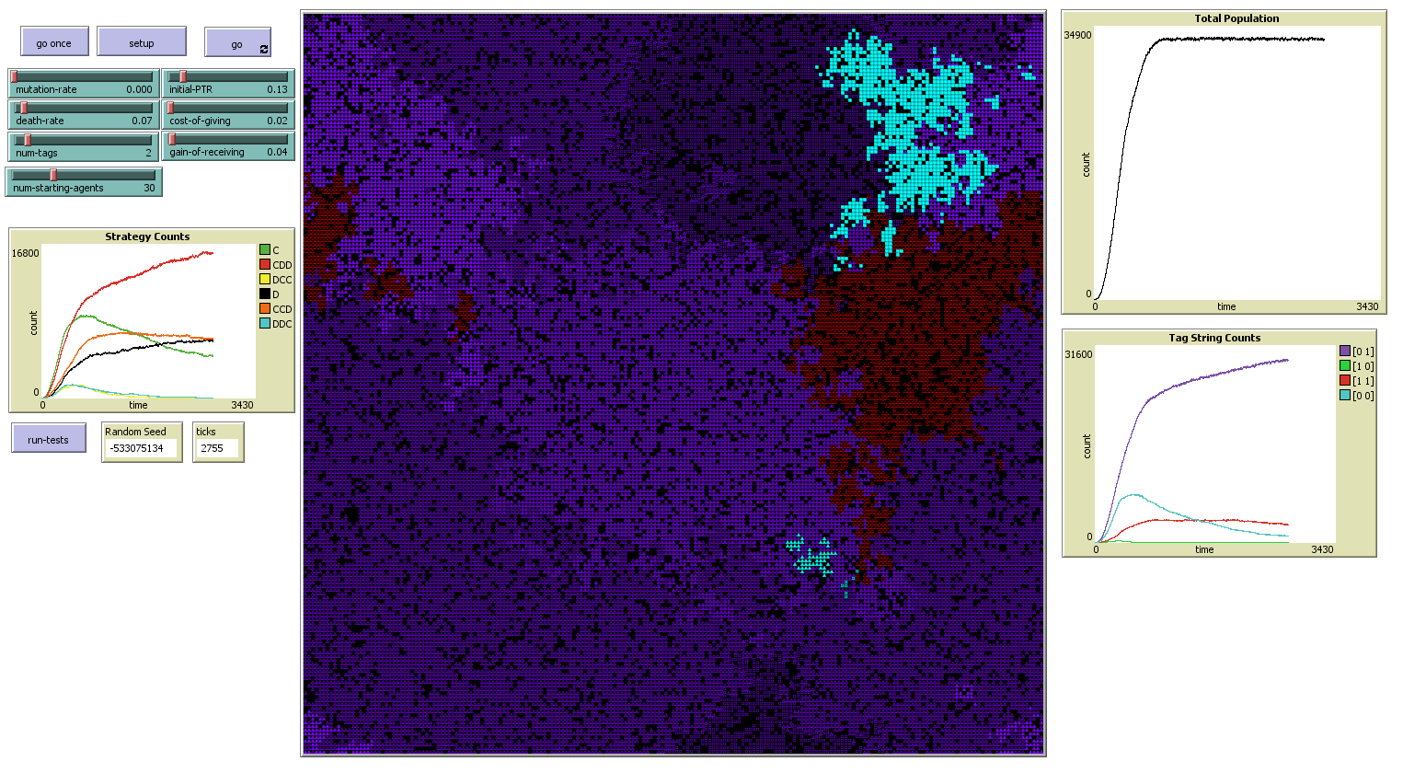

As I predicted, the red population is slowly declining as they are being eaten into by the purple ethnocentrics, and the cyans have been decimated, with only a small number remaining on the bottom right of the map and a slightly larger altruist core on the top right. With regards to each other, the purple altruists, partial ethnocentrics, and pure ethnocentrics will behave identically, so the only real competition once the other colors are gone will be from the purple egoists, who do seem to have greatly expanded their number and may take over given a long enough time horizon. I believe we have explored this particular run sufficiently though.

Looking at final results, we can see that while egoism had been on the decline at one point, its population is now beginning to slowly creep back up, and with the decline of the red population, consisting entirely of egoists, that suggests that the purple egoists must be doing quite well, so I expect they would eventually take over if I ran this model all night, but I’m not going to. A good many of the remaining reds are surrounded by of altruists or other egoists, so they may be able to survive for some time there, but they will eventually drive out the altruist population and run into the ethnocentrics.

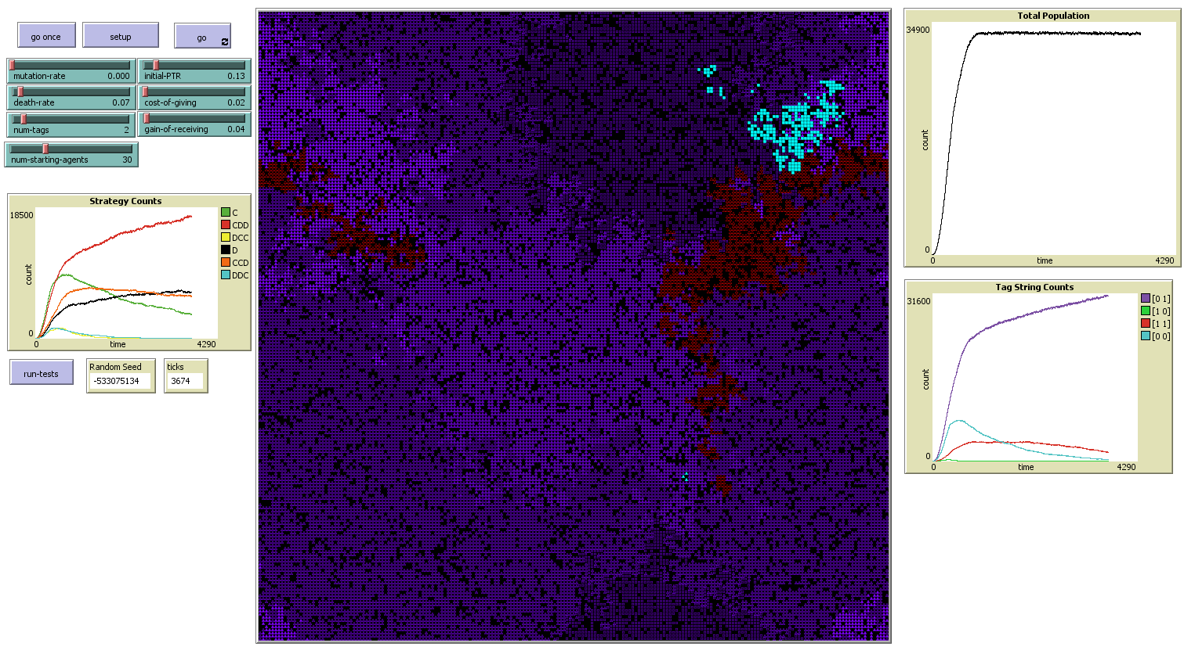

It’s easy to see how, without mutation, the end results of a model like this are heavily subject to initial conditions. While the ethnocentric strategy did gain dominance here, it’s hard to tell how much of this is down to the luck of having two populations of pure ethnocentrics of the majority color near each other and on opposite sides of the one surviving population of their opposite color, which used a cosmopolitan strategy and was quickly wiped out. Having only partial matches for other competition, the purples benefitted from any partial cooperation strategy employed by any rival. The purples were also the only pure ethnocentrists we saw and started in much greater numbers than the other colors, allowing them to easily systematically wipe out the other colors. With other colors nearly gone, a growing egoist population, and a slowing rise in ethnocentrism, we will probably eventually see the collapse of cooperation within this world and the overtaking of egoism, though that seems likely to take a very long time to happen. This would not be a bad setting to study the evolution of infighting and look at how purples might now begin to form into factions, but I don’t think that the current model logic supports it, and there isn’t time at this point to make a major revision.

We definitely saw examples of group selection in this model, given that each group employed a unified strategy, although it’s also clear that the lack of diversity in strategies without mutation was a detriment. Making mutation rate an agent parameter rather than a global and allowing it itself to be mutated and changed over time is another possible extension, but I don’t have time for that either. Here is how things ended up after 5,027 ticks:

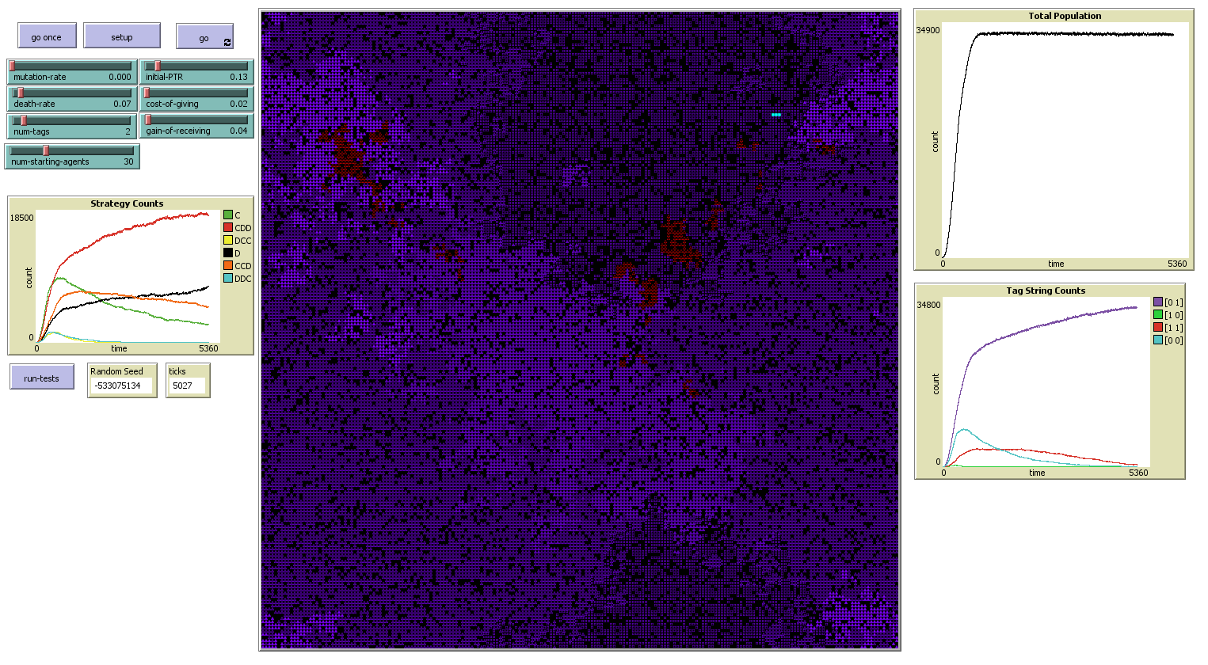

Cyan and red have been almost totally wiped out, and now egoism spreads at an ever more rapid pace like a cancer. If only they could have an enemy to fight again.

Since we are exploring mutation rate though, let us examine what even a small mutation rate of 0.1% (we had previously used 0.5%). We can use the same random seed as before to start another model run with a small mutation rate. This will create the same starting conditions, and while the introduction of mutations will alter the micro-level behavior, I think the macro-level behavior, at least to start, will be very similar. Let us see how long that continues.

Our conditions at the start are very similar to what we saw before, though we have already seen some mutations.

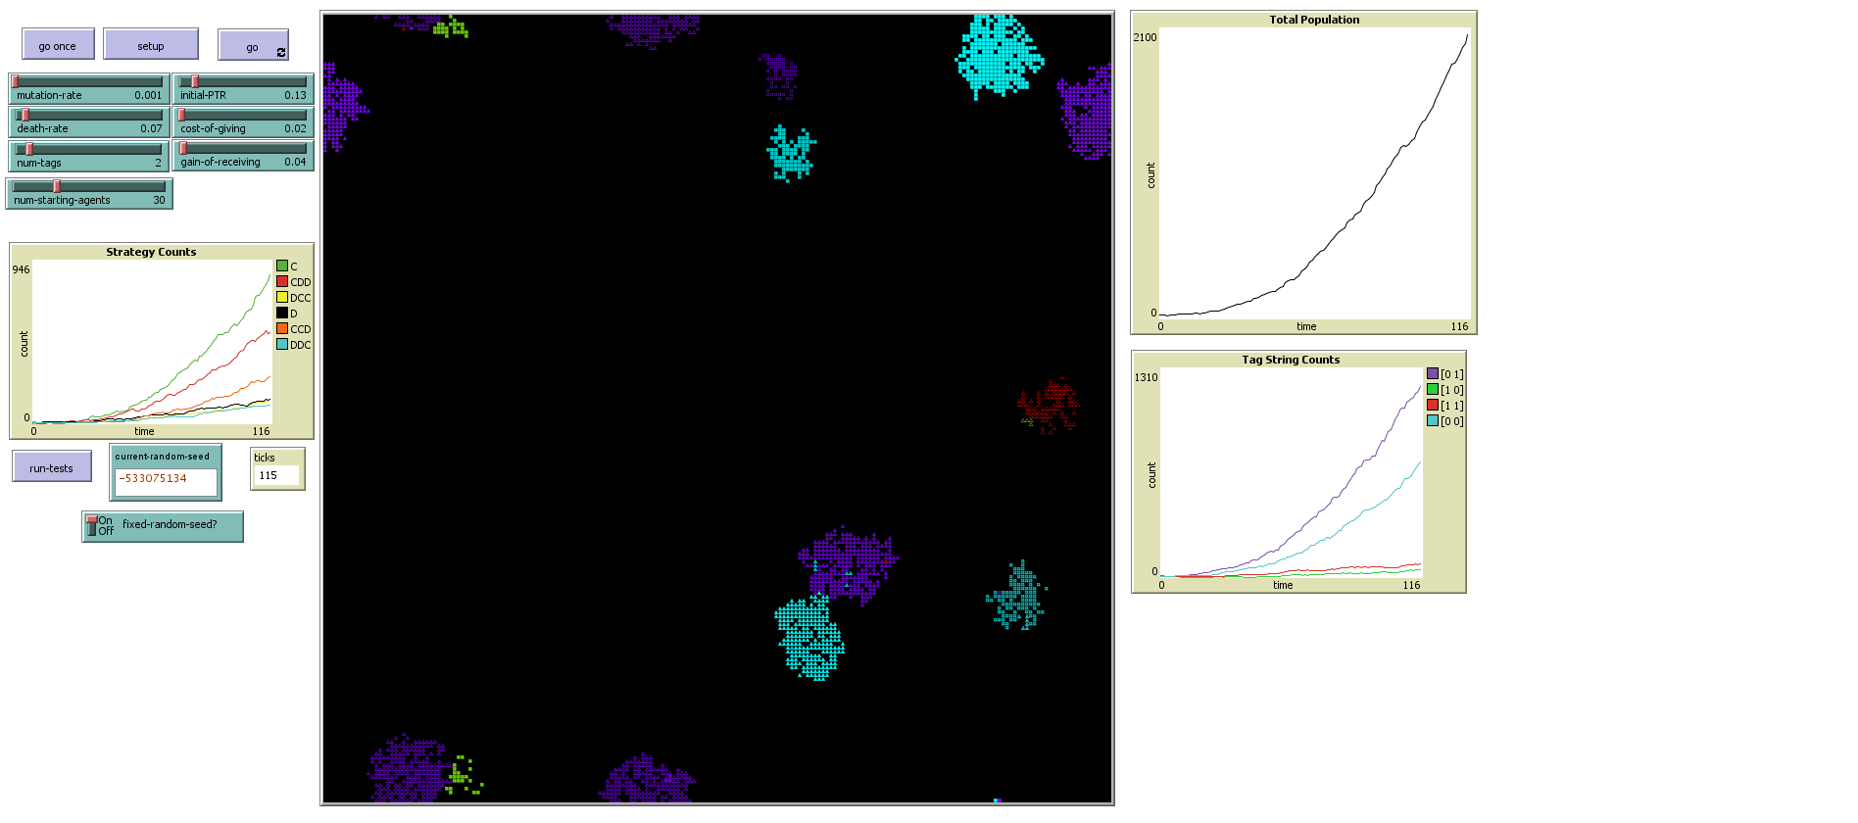

After 233 ticks, the lime population has now evolved a rapidly growing ethnocentric population. One could almost see this as a defense mechanism against the ethnocentrics around it.

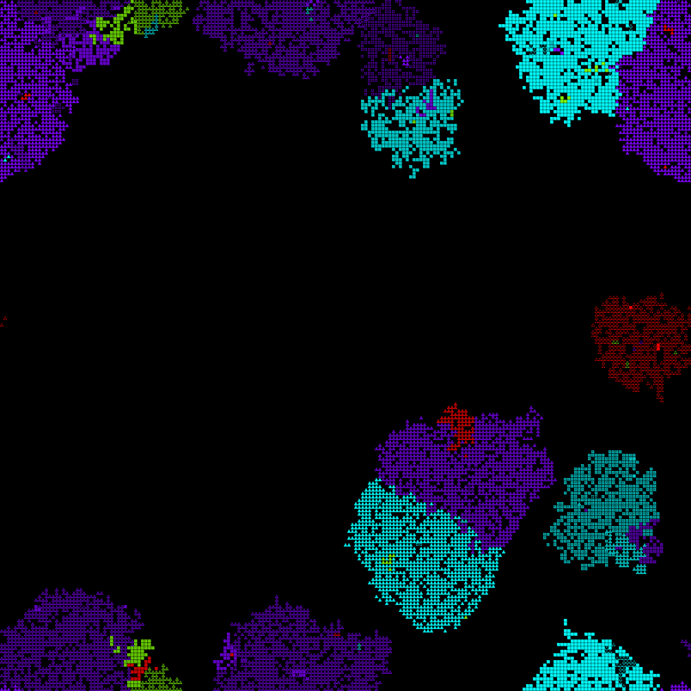

By tick 388 in our previous run, the lime population had been almost totally exterminated. Here, it is going quite strong despite being surrounded by enemies, and pockets of lime have evolved in other places as well:

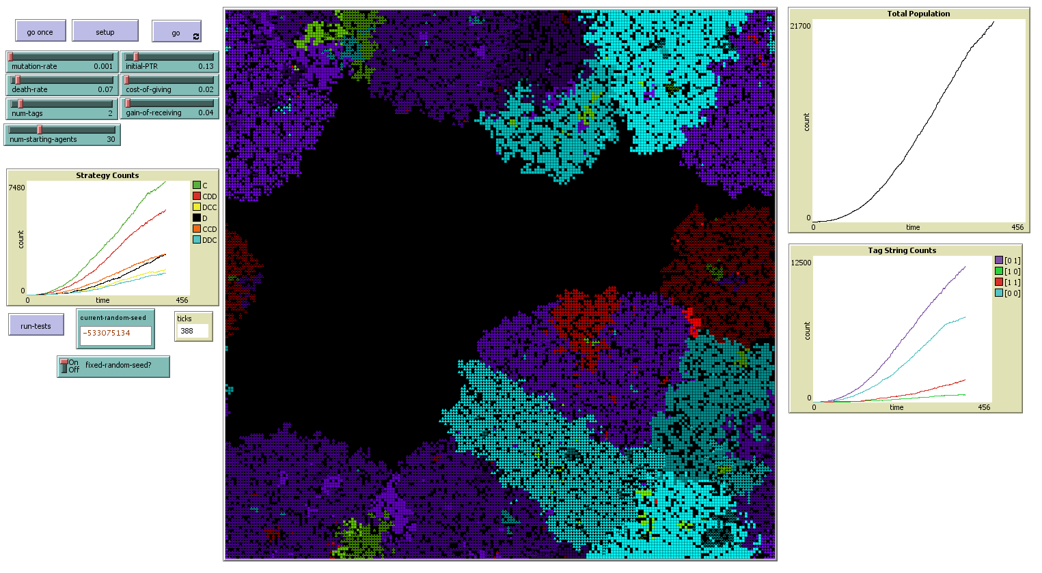

Also we see that a large enclave of red altruists has evolved in the midst of the purple altruists in the center, and is eating up quite a good chunk of their territory.

By time 511, a population of cyan ethnocentrics has developed in the middle of the lime ethnocentrics, so now they are competing for territory:

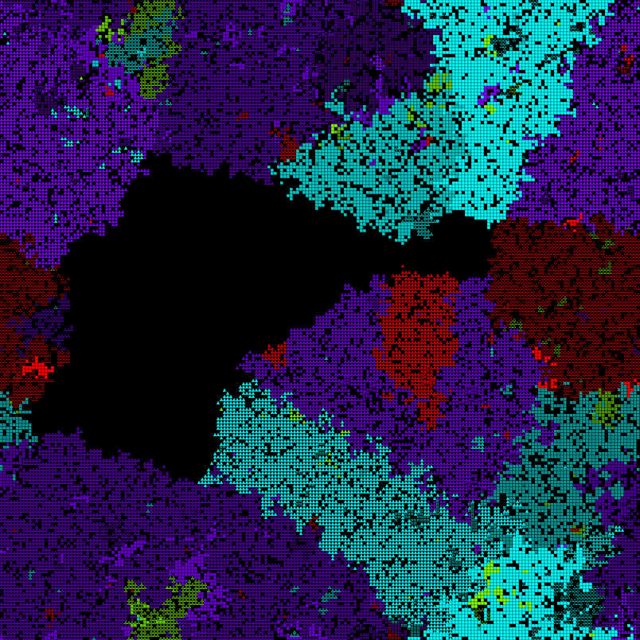

Overall population growth has proceeded very similarly to in our previous run, though we see much more diversity in color and strategy now. By step 831, the world has been completely filled. Strategy trends are similar. Though it took a little longer than before for ethnocentrism to overtake altruism, now that it has, altruism is declining much more rapidly. We also see that egoism is growing much more quickly than before. By this time in our previous run, limes were completely extinct, though here, the initial lime population is growing strongly after having evolved ethnocentrism, and the initial cosmopolitan population is almost totally gone.

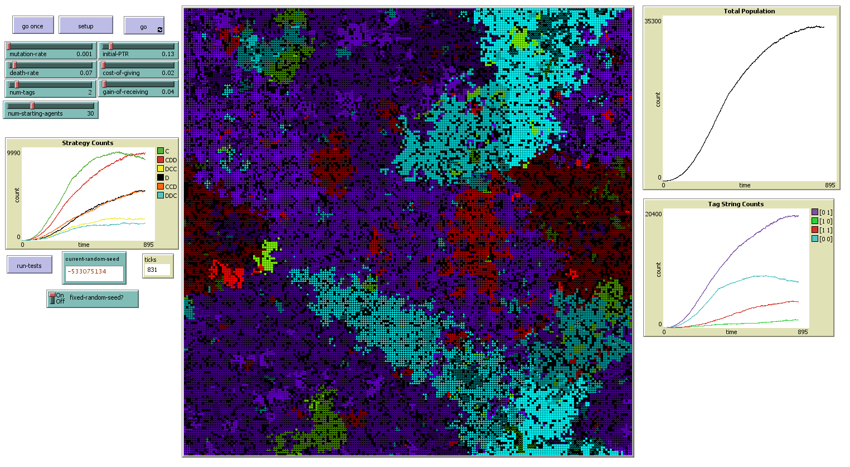

By this point in our previous run, change had become much more gradual. Now though, things are happening quickly. Altruism is declining rapidly, as is partial ethnocentrism, while egoism and pure ethnocentrism are on a quick rise. We also see that while purple still has an advantage in numbers, it is not as strong as before, with red and lime populations both rising, and cyan declining more slowly than it had before:

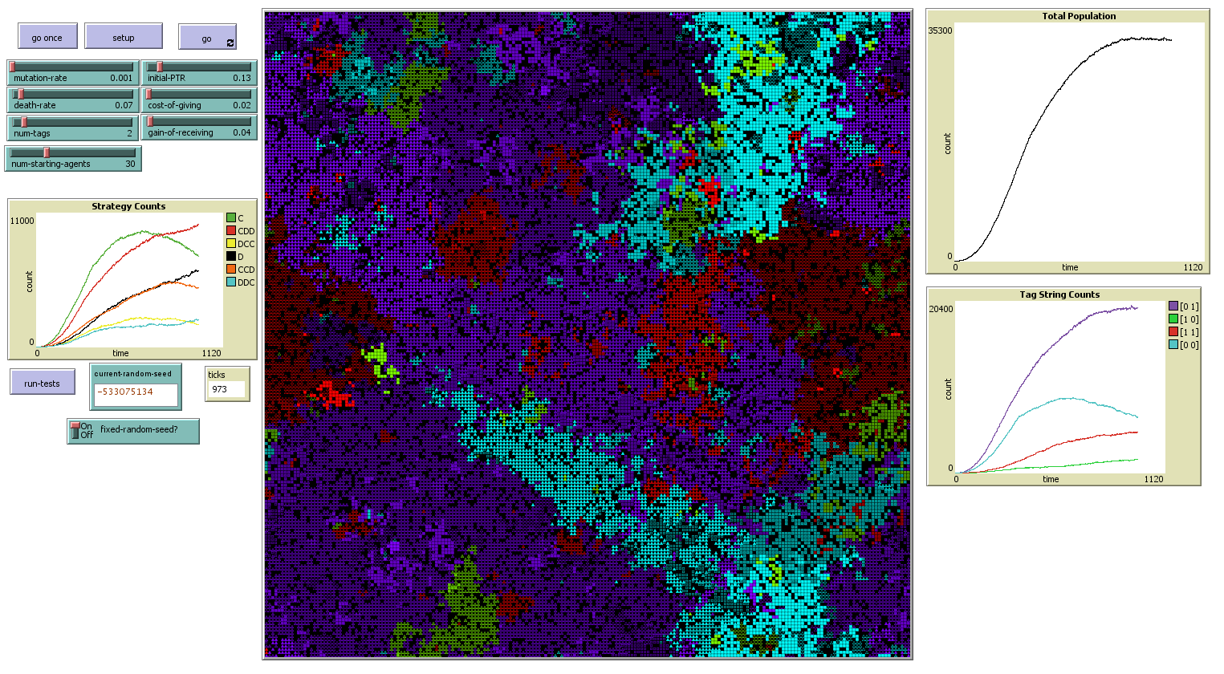

By time 1879, the world we see much more closely resembles what we’ve seen in previous runs with higher mutation rates:

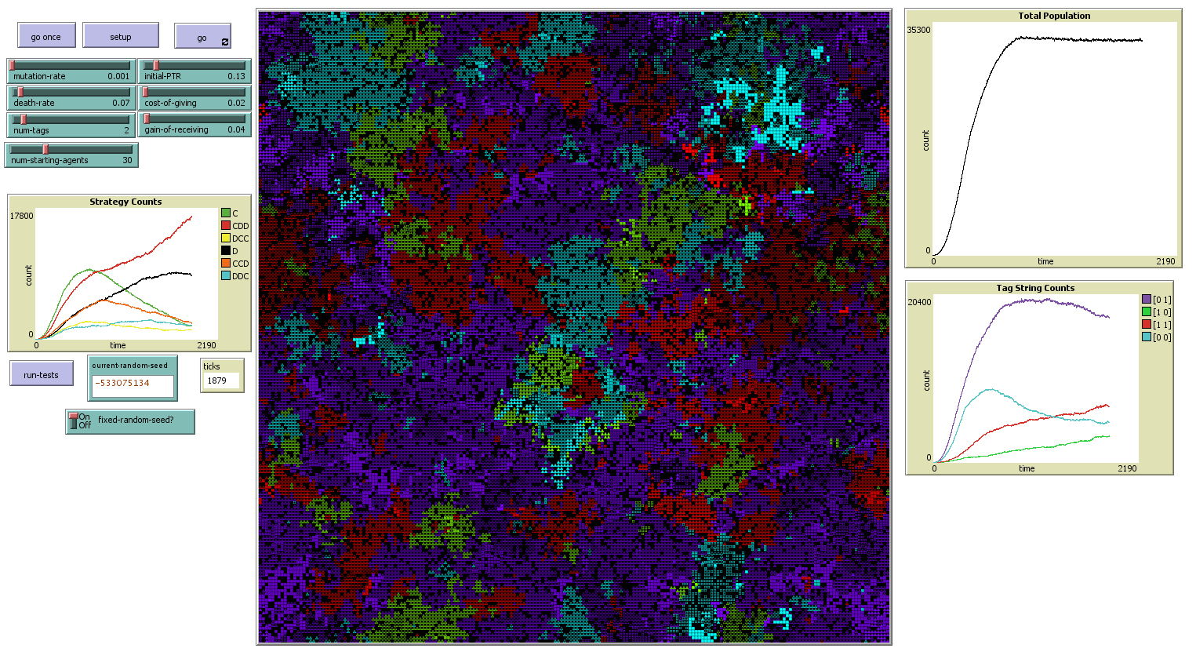

Purple population is beginning to decline, cyan is beginning to recover and climb again, and red and lime are both rising rapidly. In terms of strategy, altruism and partial ethnocentrism are now almost totally gone. Egoism had had an initial surge but is now beginning to decline, and pure ethnocentrism is rising rapidly. It seems that even with more subtle variations allowed in similarity and difference, pure ethnocentrism is still easily the most powerful strategy for reproductive success, as partial ethnocentrism still has a disadvantage over it with different colors, of which there are now many more. It is quite easy to conclude that as this run continues, we can expect that color populations will eventually equalize and pure ethnocentrism will become dominant.

We can see from this that even a very small mutation rate can make a giant difference in the evolution of a population. While we have not explicitly included learning at an individual level, these mutations and evolution allow learning at a population level, ultimately allowing populations to grow smarter and better ensure (from an ethnocentric perspective) their own survival.

By 2700 ticks, the purple population has rapidly declined and been overtaken by the red population. Egoism has begun a sharp decline, and pure ethnocentrism has again proved itself dominant. We have now reproduced essentially the same dynamics we have seen before with a much smaller mutation rate.

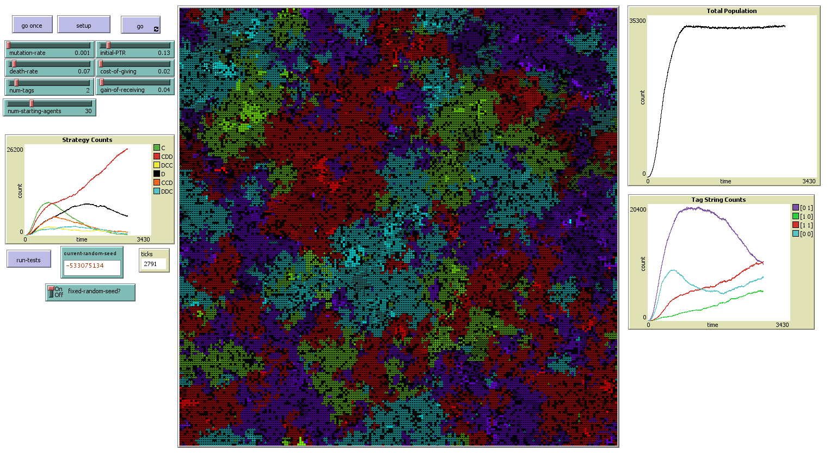

One major difference is that with this lower mutation rate, the clusters of color that we see are much larger than they were with higher mutation rates. This makes sense as fewer mutations of color within a cluster mean that each cluster has much more opportunity to grow larger and more homogeneous.

By 3834 ticks, the purples, once the most dominant population by a wide margin, have now moved into the smallest minority:

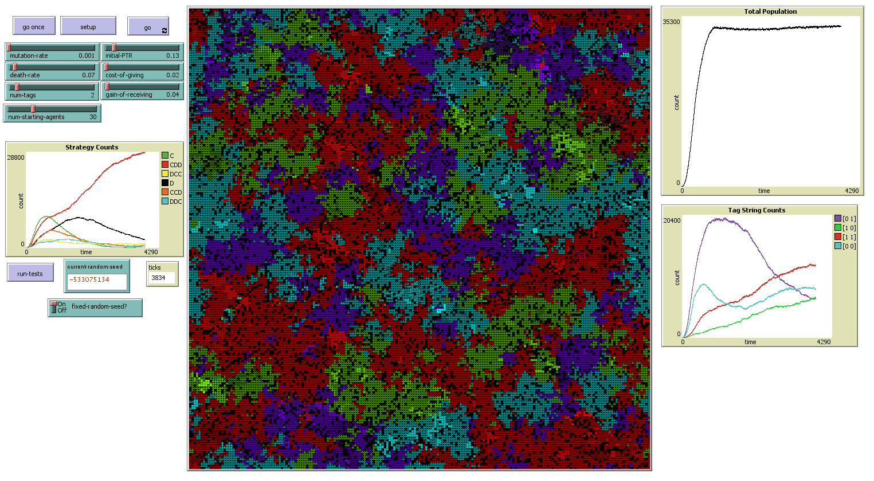

Why is this? Remember that there was initially a large population of purple altruists, egoists, and partial ethnocentrists. These strategies existed in the other colors as well, but because of their small size, were quickly eliminated. Purple’s dominant position allowed these strategies to survive much longer, perhaps creating a certain complacency, while the other colors were forced to adapt more quickly. Now that it is in the minority and in rapid decline, purple will no doubt have to adapt better (from an evolutionary standpoint) strategies for its own survival and growth as well.

While Axelrod’s works on the evolution of cooperation have tended to disparage pure altruism and assumed that the survival of cooperation required a means to test for free riders, these results show that that is only true when resources are sufficiently scarce. The only scarce resource in this model is space, and when space is plentiful pure altruism does quite well. It is only when space becomes scarce that a greater degree of suspicion becomes an advantage. The most rapid population growths we have seen in these simulations have occurred with pure altruism when there was ample free space to grow.